ALTARUM POSITION PAPER - EHR INFORMATION DESIGN

Background
Health Information Technology (HIT) holds the promise of creating transformational change in the way healthcare is delivered—improving quality, enhancing safety and reducing costs. The increased availability of patient information and decision support at the point-of-care has tremendous potential for reducing errors and increasing evidence based care delivery. However, HIT solutions that fully leverage available information and are capable of seamless integration with clinical workflows are truly still in developmental stages. The Electronic Health Record (EHR), Computerized Physician Order Entry (CPOE) and decision support capabilities available in the market today fall short in both form and function. Specifically, EHRs are complex information systems that traditionally have been very difficult to learn and use in an efficient and clinically effective manner. These difficulties coupled with costs have led to resistance in physician adoption and utilization, limiting the overall impact HIT has had on our health system. Through past and current projects Altarum aims to employ its Systems Research Methodology and informatics experience to help improve the effectiveness and utilization of health information systems.

Altarum Institute
Altarum is a nonprofit research and consulting organization with roots that go back to 1946. Over the years, our mission has become focused on improving our Nation’s health by solving complex health systems problems with the integration of research, technology, analysis, and consulting skills. Altarum’s Health Informatics practice applies systems research principles to help Federal and State agencies advance the use of information technology to most effectively leverage health information, improving population health. Past projects have included the design and development of several state public health information systems such as the Michigan Disease Surveillance System and the Michigan Care Improvement Registry. (see figure 1 on next page for example of Altarum’s approach to health informatics)

Current Project
AHRQ seeks to evaluate the applicability of information design principles to the EHR Graphical User Interface (GUI). Altarum, James Bell Associates and faculty from the University of Michigan’s Schools of Medicine, Public Health and Information have been awarded a contract to address phase I of this project; the analysis of current information design theories and their applicability to the design of electronic health records. Understanding the multiple perspectives that can affect the utilization of EHRs the JBA/Altarum team plans to explore issues from several perspectives including that of the physician (addressing work process, practice style and team collaboration), cognition (addressing ontology, information search, decision processes and comprehension) and information design (human factors, layout, architecture and visualization). Through combining the research from the many disciplines involved in these perspectives the JBA/Altarum team hopes to present AHRQ with a comprehensive and directed recommendation for future funding efforts in EHR information design. This workshop would provide a valuable opportunity for a member of our team to both contribute findings from our current research and to gain knowledge on current developments in the area of the quality design of EHR technologies. (see figure 2 on next page for visual description of project approach)

Figure 1. Health Informatics & Systems Research
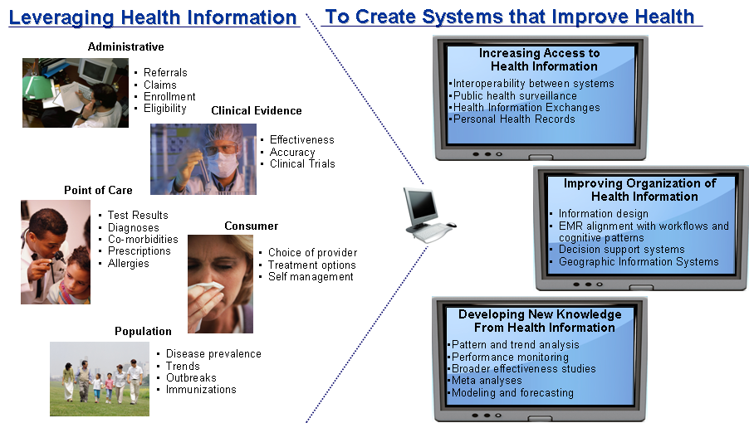

Figure 2. Perspectives of Health Information Technology
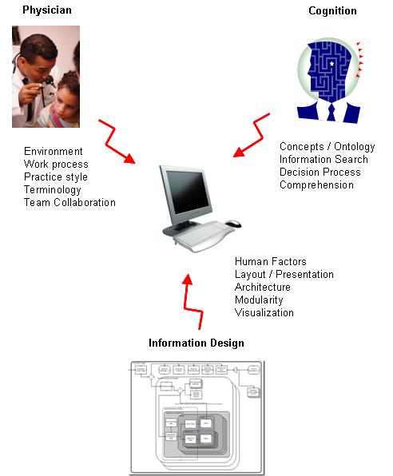

Langley J, Beasley C. Health Information Technology for Improving Quality of Care in Primary Care Settings. Prepared by the Institute for Healthcare Improvement for the National Opinion Research Center under contract No. 290-04-0016. AHRQ Publication No. 07-0079-EF. Rockville, MD: Agency for Healthcare Research and Quality. July 2007.
Zhang, J, Patel, V. L., Johnson, K. A., & Smith, J. W. (2002). Designing human-centered distributed information systems. IEEE Intelligent Systems, 1094-7167

