Web-siteStarter: Exporting photo library to the web
Richesh Ruchir (richesh@yahoo.com)
Dept. of Computer Science, University of Maryland at College Park, MD 20742
http://www.cs.umd.edu/hcil/photolib/

Table of Contents
Introduction 4
Evaluations 4
Subscription-based Libraries 4
Non-profit Libraries 5
Search Engine Libraries 6
Description of Problem 6
Brief Background of PhotoFinder 7
System Analysis 7
Design 8
Navigation 8
Library Viewer 8
Collection Viewer 8
Image Viewer 9
Name Browse 9
Implementation 9
Software 9
Server 10
Testing 10
Software 10
Server 11
Evaluation 11
Limitations 11
Future Extensions 11
Appendix A : Comparison Charts 13
First Category Chart: Subscription Based Libraries 13
Second Category Chart: Non-profit Libraries 15
Third Category Chart: Search Engine Libraries 17
Appendix B : 1st Category Screenshots 19
Corbis.com 19
PictureQuest 20
Appendix C : 2nd Category Screenshots 23
World Bank 23
NOAA 24
Library of Congress 25
Appendix D : 3rd Category Screenshots 26
Lycos 26
Yahoo! 27
Altavista 28
Appendix E : System Flow Chart 30
Appendix F : Web-siteStarter Screenshots 31

Introduction

A recent survey conducted by IDC shows that 31 percent of US homes have Internet access and digital imaging capability, but not many of these households actually use these two technologies together. People use the computer to print their digital images but they do not have a good way of managing these images. Through the Internet people can send electronic mail, have real time conversations, share pictures, and ideas with any one in the world. The Internet is not limited to just sending and receiving pictures; it can also be used to manage pictures, which would make it easier to access an image and catalog albums. Even though Internet allows for people to store and manage their pictures, none of these web sites give the user the capability of searching based on who is in the pictures.

Evaluations

There are many web sites that allow users to export their photos on to the web. Once exported some of sites provide users with variety of features to manage their collection while others only offer limited viewing options. Some sites allow users to search a massive database for research and personal purposes. This paper discusses nine such web sites divided into three major categories, subscription-based libraries, non-profit libraries, and search engine libraries. Subscription-based libraries include corbis.com, picturequest.com, and sciencephoto.com. The non-profit library contains worldbank.emotion.com, photolib.noaa.gov, and memory.loc.gov. Search engine libraries category includes multimedia.lycos.com, gallery.yahoo.com, and altavista.com.
(Please View Appendix A for a Comparison Chart)

Subscription-based Libraries

Subscription-based libraries don't require the user to pay a fee instead they want the user to register for advertisement purposes. These sites present the images very nicely with user-friendly features. Corbis.com utilizes an icon-based navigation where relevant icons are used for certain actions to be performed on an image. These icons include a magnifying glass for zooming, an envelope for e-mailing the image, etc. Even though the site includes a legend, which explains what these icons mean in detail, it can still be frustrating for the user to decode the icons. In order to use such features on sciencephoto.com the user has to first click on the image, which brings up another window with a larger image and the options. This process can be cumbersome for the user if they have to navigate through many images. The solution adopted by picturequest.com seems to best serve this functionality. Picturequest.com uses short text instead of icons thus eliminating the need for a legend and making it easier for users to navigate. Corbis.com uses dynamic left side navigation bar, which gives viewers access to different libraries and collections. There is no navigation on picturequest.com or sciencephoto.com that allows a user to easily go from one collection to another. On picturequest.com the display format of the search results could be changed to "image only" or image and text" thus allowing the user to scan through just images or they can look for a specific text. This feature does not exist on corbis.com or sciencephoto.com thus limiting the accuracy of the search results. Corbis.com also allows users to perform searches within collection thus helping the user refine their search for a particular image. Despite their differences these three sites share common features and functionality. All three sites allow viewers to choose the number of photos to be shown on a single page this helps the user decide for themselves how fast or slow the page will load based on their connection, viewers can choose anywhere from nine to seventy-two pictures per page. All three sites show total number of images found and provide page by page navigation which helps viewer put their search result in perspective as to how long its going to take to find the particular image they are looking for. All three sites exhibit horizontal image arrangement and have static navigation on top and bottom of all pages to make navigating the site easier. Each site uses different thumbnail sizes on their collection pages, corbis.com uses 128 x 95 pixels, picturequest.com uses 128 x 144 pixels, and sciencephoto.com uses 85 x 40 pixels. All three sizes are optimal for the page layout of each site. These sites allow the viewer to create a personal portfolio, also called a "lightbox", for easy future access to selected images. One interesting feature implemented by sciencephoto.com is the ability to view the collection in a split screen window where the viewer can click on an image in one frame and the image enlarges in another frame. This feature allows users with high bandwidth connections to traverse the images much faster.
(Please View Appendix B for Screenshots)

Non-profit Libraries

Second category includes non-profit sites such as worlbank, NOAA, and library of congress (LOC). These sites have very basic search capabilities with very few or no features at all. Worldbank uses short text with a legend for functionality but the other two sites do not provide simple functionality like zooming or emailing. NOAA site does not have a static top or bottom navigation, which makes it hard for users to continue browsing images. Worldbank and NOAA show total number pages the search results is on and allow user to navigate page by page whereas the LOC site does not show total counts or allows page by page navigation, thus making it difficult for a user to narrow down their search. The Worldbank site allows users to change display format to "image only", "text only", and "image and text." This feature is very helpful to users of different connection speed to efficiently browse the images. NOAA and LOC have a vertical page layout whereas Worldbank has a horizontal page layout. Vertical layout does help accommodate more results on page but also requires users to scroll. Worldbank provides the ability to create a "lightbox" which helps future access of selected images. Due to vertical layout the NOAA and LOC sites can return about 50 images as search result on one page whereas Worldbank only shows 12 per page. None of these sites provide zooming or emailing capabilities, which limits viewers' ability to better view the images. Not having these features may have resulted from lack of funds from advertising and lack of viewer response to the site.
(Please View Appendix C for Screenshots)

Search Engine Libraries

Third category is made up of image libraries provided by search engines such as Lycos, Yahoo, and Altavista. Altavista's gallery uses full text links for more information, zoom, and emailing whereas Lycos and Yahoo don't provide these options for an image at all. All three sites use static top and bottom navigation and dynamic navigation, which allow viewers to backtrack their path making navigating very simple and easy. Lycos's multimedia gallery only shows previous and next page as navigation on the search result page whereas Yahoo and Altavista allow viewers to browse through multiple result pages. The choice of display format is not available on any one of these sites, and Altavista's popup windows for each image can make a viewer frustrated. Yahoo offers viewers capabilities to add an image to their own personal "photo albums" given that they have a Yahoo ID. Viewers can also send these images as greeting cards or put it on their home page simply by clicking a button. All three sites return about 9 to 10 images per page to decrease the page download time. Lycos's multimedia gallery offers features like zooming, information about the picture, ability to see "People who did this search also," shows dimension on thumbnails, and on the image page the next image is shown as a thumbnail. These features make the Lycos site much easier to browse for the viewer. Yahoo offers a unique feature which allows users to view the set of images as a "slideshow" where the images cycle through at a four second interval, thus making it easier to go through a results page.
(Please View Appendix D for Screenshots)

The Web-siteStarter application is created from the information collected from researching these nine sites. Web-siteStarter utilizes the good features found on these sites and avoids features that seem to make image browsing difficult for viewers. After researching these sites the WebStarter application has also come up with a few new implementation techniques that make image browsing easier for users.

Description of Problem

The PhotoFinder is client-based software that allows users to manage, annotate and search their images. With the advent of the Internet, all software in the market today has a way to utilize the vast knowledge, accessibility, and storage capabilities of the Internet. The Web-siteStarter application will help the current PhotoFinder software migrate to the Internet.

One of the major collections that the PhotoFinder is used to manage is the ACM’s annual Sig-Chi conventions. From each year’s conventions there are approximately two thousand pictures generated of events and people. Although PhotoFinder allows for a user to manage and annotate these pictures it does not make these pictures available on the web for people who attended these conventions. In this day and age almost everyone’s first question is, “Where can I see it on the web?” ACM could use one of the web sites evaluated in this paper to allow others to view these pictures but none of these sites allow for easy multiple uploading of files. Also, each picture would have to be annotated once again and viewers could not search based on annotations. Having a client-side application that can easily export thousands of pictures to the web would be much easier to use since all the managing and annotating can be done on a single computer without having to deal with lag and down time of the Internet. Being able to view and search pictures, based on annotations, on the Internet would be a great asset to any organization.

Brief Background of PhotoFinder

PhotoFinder is a powerful tool for organizing digital pictures on a PC. Photos can be organized into general categories called Libraries and further sorted into Collections. Details about the Libraries and Collections including descriptions, keywords, date, locations, etc. can be stored in PhotoFinder so that photos can be easily found. Specific data for each photo is also stored in PhotoFinder. The people in each photo can be annotated with drag and drop labels, which can be used to find all of the pictures with a specific person in them. PhotoFinder is a very effective means of storing and organizing digital pictures. PhotoFinder currently has a web-publishing feature. However, it is simply a collection viewer that allows users to share a collection of photos via a web page. It does not allow a story to be told using the photos. (John Prebula)

System Analysis

Before starting the project we conducted extensive research on other sites which had close resemblance to what the web-siteStarter was being designed for. At first it was decided to create a generic tool that will allow any PhotoFinder library to be exported to the web. This tool would be user friendly and could be used by a novice user. As the project progressed it became necessary to have the ACM libraries exported to the web by a certain deadline. The idea for a generic tool still existed but more focus was given to the ACM libraries and the hosting of these libraries on the web by ACM.

After conducting an analysis of the ACM network infrastructure it was decided that the web-siteStarter would be hosted on a UNIX platform with mySQL as the database. Since ACM wanted to maintain this site, we also had to make sure that the tool was simple to use and support. Even though the project was initially designed to use static HTML pages, it became evident that a dynamic approach had to be taken in order to accomplish this task. JSP was chosen as the dynamic language in which the tool would be implemented. JSP is a hybrid of JAVA and HTML; it has the advance power of Java combined with the simplicity of HTML.

Once the tools were decided, the analysis focused on user interface. In order to keep the web site simple and user friendly it was decided to use no frames, limited number of tables, static navigation, and style sheets.
(Please View Appendix E for Flowchart)

Design

Web-siteStarter tool helps a photoFinder user export their entire library to the Internet. This tool generates a functional web site using the existing photoFinder database and allows users to make their images accessible to public. The web-siteStarter is divided into four different sections library viewer, collection viewer, name browse, and an image viewer. Even though this particular Web-siteStarter tool has been customized for ACM, it can still be easily transformed into a generic tool in the future.
(Please View Appendix F for Screenshots)

Navigation

Once the web site is generated, each section of the site has the same navigational links on the left side. The side navigation bar allows for users to go to another library or its highlights section, go to search by name, or search the entire database for pictures. The site also has static top and bottom navigation, which allows users to visit different sections of the site. All sections include a dynamic navigation, which allows users to backtrack to their previous selections.

Library Viewer

The library viewer allows users to see existing collections in the library by displaying the first image from every collection as the thumbnail. This page provides the collection title, description and total number of photos in each collection. Clicking on a collection thumbnail on the library viewer takes users to the collection viewer, which shows thumbnails of all images in the collection.
The library viewer is implemented using Java Server Pages (JSP), Java containers and database. The JSP pages utilize the Java containers to store information retrieved from the database about each collection and the in the library and displays them by iterating through the queried results.

Collection Viewer

This page also includes detailed information like the description, stating and ending date, and location about the collection. The image layout on the collection viewer allows users with different resolutions to see the most optimum number of thumbnails in a row. If the collection viewer window is resized then the number of thumbnails on each row automatically changes to fit the screen. The collection viewer is implemented using Java Server Pages (JSP), Java containers and database. The JSP pages utilize the Java containers to store information retrieved from the database about the photos in the library and displays them by iterating through the queried results.

Image Viewer

Clicking on any thumbnail opens image viewer in a new window, which shows the image and all the information associated with that image. This information includes names of the people in the photo, a caption, date, location, and at what event the photo was taken. The image viewer also shows all annotations present on the image. Any information about the picture not present in the database is not shown on the image viewer. The image viewer allows the users to go to previous or next pictures in the collections, and also provides a link back to the collections page. The image viewer is also implemented using JSP pages, which utilize the Java containers to store information about each picture and the entire collection.

Name Browse

The name browse allows viewers to look for a particular person's images in the library. This page has a links of all the names in the library and the number of photos of each person in the library. Clicking on a name opens up the collection viewer, which generates a dynamic collection of the person's photos. If the person appears in more than one collection than the link is redirected to the search page, which queries all three databases for that particular name and provides the user with links to those collections. Clicking on a thumbnail takes the users to image viewer, which shows a larger image and all the information associated with the photo. At this point the users can see what collection in the library each photo belongs to and they can see the original collection by clicking on the collection name. They can also go to previous or next picture in the dynamic collection for that name.

Implementation

Software

The Web-siteStarter is implemented using Java Server Pages (JSP), Java containers, mySQL database, and Apache Tomcat server. JSP is a third tier language, which allows for database queries and dynamically outputting the results to client's browser. The four sections mentioned earlier are implemented using JSP. The Apache Tomcat server compiles the JSP pages and returns the appropriate HTML page to the client. The database used by web-siteStarter is the exact same database generated by PhotoFinder exported to mySQL database. Each click performed by the user sends certain parameters to the next section, which based on those parameter performs queries that generate the results page. The name browse section was initially created to de fully dynamic, therefore when a viewer visited the section it would create a list of name and display it. As the project progressed, it was realized that generating names dynamically considerably slowed down the page load, and therefore we came up with a semi-dynamic solution. The solution to this problem was to generate a list of names and links, based on the libraries, statically at the time of the site export thus lowering the page load time. Since the site would have to be exported every time there were new names added, a “name generator” was added to this tool. This tool queries the existing databases and creates a list of non-duplicate names as a link to their appropriate collections.
The database used in generating different sections of the web-site is the same database used bye PhotoFinder software, thus exporting it was an easy process.

Server

The Tomcat server is an open source HTTP/JSP server, which utilizes a servlet based JSP compiler to compile any page requests with a ".jsp" extension. We also chose Tomcat because it provided portability that the Web-siteStarter required. Tomcat can be run on any operating system currently available on the market without making any changes to the tool itself. Since the Tomcat server is free software it does not come with good support. In order to install Tomcat a few configurations have to be made to the operating system. Tomcat also requires JAVA SDK 1.3 in order to compile Java code. The JAVA SDK 1.3 is also a free package distributed by Sun Microsystem (http://java.sun.com). This requires the administrator to configure environment and system variables, which point to the JAVA SDK 1.3 directory.
The development of the tool initially started on Microsoft Windows NT platform using Microsoft Access database, but was quickly moved to a UNIX platform running Red Hat Linux and mySQL database. The remaining development was done on the UNIX machine and was tested on another UNIX machine with the same configuration at University of Maryland.

Testing

Software

Software was first tested on Microsoft Windows NT platform running Tomcat server. After fixing compiler errors on Windows NT platform the tool was transferred to a UNIX server. Once the tool and the database were running without any compiler errors, we asked a few HCIL staff members to test and give feedback on the tool. System testing revealed many errors that were caused by clicking a certain link and by visiting pages in certain order. Slowly all the major bugs were fixed, and the tool was ready to go through functional testing.
During the functional testing we tested the tool on different platforms and browsers. ACM Web-siteStarter was tested on different versions of Microsoft Internet Explorer and Netscape Navigators. During this testing we found many incompatibilities between the browsers and had to make significant changes to the tool.
After the system testing, we moved our focus on usability testing. During this phase we asked users to give us feedback on the usability of the tool. These changes were necessary for the tool to be user friendly. Many suggestions were made to not have user click through multiple pages to view an entire collection since there could be thousands of pictures in a collection. We changed the tool to show all pictures in a collection on one page
Database export testing revealed that the database generated by PhotoFinder software had a directory structure problem. The locations for the pictures were stored as uppercase characters and since Java is a case-sensitive language it caused an error in the tool. A decision was made to fix the current ACM database to work with the Web-siteStarter and in future the PhotoFinder software would be altered to store all locations as lowercase characters.

Server

In order to test the Tomcat server we first installed it on Microsoft Windows NT workstation due to lack of UNIX server availability. The code was implemented on Windows NT platform then switched to UNIX server. The implementation had no issues with the transfer, which as a result helped us testing for portability.

Evaluation

The goal of the Web-siteStarter was to create a generic tool to export pictures from PhotoFinder to the web. Due to the immediate deadline for the ACM picture collections to be on the web, the project focused mainly on generating a web site to support ACM’s collection. Although focused for a few specific libraries, the implementation of this tool can easily be modified to support any library.

Limitations

Since this project focused mainly on ACM’s collections it has created many limitations in the tool. The tool currently has implemented only three libraries of the ACM and these libraries are hard coded. This causes limitations on future additions of libraries to the web site. The current tool also limits the searching options; the tool only searches the names and captions. Currently the databases have to be reorganized and modified in order to work with the Java architecture, this limitation creates some manual work to be done. One of the limitations of the tool exists in the image viewer where the image is loaded fully then resized to fit the screen. This process can take a longer period of time on slower Internet connections.

Future Extensions

Future extensions could include the ability to support multiple libraries. Ability to search pictures by date and location could also be a future enhancement. PhotoFinder’s database can be standardized to eliminate the manual work currently required to meet the specifications for Java architecture. The JSP pages can also be re-designed to fit the new "Model View Controller" approach proposed by Sun Microsystems. This approach allows all processing to be done by a central Servlet unit called "controller" which allows the developer to easily make modifications in the future. It also takes long lines of code away from the JSP pages and puts them into Java Servlets. Since Servlets run on the server it also makes the response time of the JSP pages faster. The images can be automatically resized before loaded onto the site so that the image viewer will not take longer to load in a slower Internet connection.

Appendix A : Comparison Charts

First Category Chart: Subscription Based Libraries
Features: | Corbis.com | picturequest.com | sciencephoto.com
More Options | use of Icons | use of short text | have to click
Legend | shows what each icon means | does not explain short text | does not explain short text
Static Navigation | Top and Bottom | top and bottom | top and bottom
Dynamic Navigation | left side gives easy access to other collections and libraries at all times | no dynamic navigation user has to search every time | user has to go back to subject index for different subjects
Page Navigation | shows total number of pages with back and next navigation | shows total number of pages with back and next navigation | shows total number of pages with back and next navigation
Show Count | Number of photos found and the number of pages help put amount of time to view in perspective | Number of photos found and number of pages help put amount of time to view in perspective | Number of photos found and number of pages help put amount of time to view in perspective
Display Format | N/A | "Image Only" or "Image and Text" | N/A
Page Layout | horizontal photo arrangements | horizontal photo arrangements | horizontal photo arrangements
Personalize | Ability to create personal portfolios for future viewing | Ability to create a lightbox for future viewing | Ability to create a lightbox for future viewing
Photos per page | 9  Users can specify how many photos they want to view on one page (9, 18, 36) thus letting the user decide the download time based on their connection | 12  Users can specify how many photos they want to view on one page (12, 30, 60) thus letting the user decide the download time based on their connection | 18  Users can specify how many photos they want to view on one page (18, 36, 72) thus letting the user decide the download time based on their connection
make search easy | Within collections there are sub-categories which allow the use to refine their results | User has to do a text search which creates the collections | user can go back to subject index or conduct another search
other features |  |  | • ability to do split screen

Appendix A (Contd.)

Second Category Chart: Non-profit Libraries
Features: | worldbank.emotion.com | photolib.noaa.gov | memory.loc.gov
More Options | use of short text | no options | no options
Legend | Explains what each short text refers to | no legend | no legend
Static Navigation | Top and Bottom | no static navigation | top and bottom
Dynamic Navigation | no dynamic navigation user has to search every time | no dynamic navigation the user has to use the back buttons on their browsers | no dynamic navigation
Page Navigation | shows total number of pages with back and next navigation | allows users to navigate through result pages but its at the bottom of the page | does not show total number of pages only allows previous and next page
Show Count | Number of photos found and the number of pages help put amount of time to view in perspective | does not show number of photos found | does not show number of photos or pages found
Display Format | "Images", "Text", "Images and Text" | no choice | text only
Page Layout | horizontal photo arrangement | vertical photo arrangement | vertical text arrangement
Personalize | Ability to create a “lightbox” for future viewing | no personalizing capability | no personalizing capability
Photos per page | 12 per page;  user cannot specify how many pictures per page | 49 photos per page (no choice of changing) | depends on the search result
make search easy | User has to do a text search which creates the collections | user cannot do text search user has to go back to the list of collections to view other images | user cannot simplify the search
other features | • no zoom capabilities  • very detailed information about the picture

Appendix A (Contd.)

Third Category Chart: Search Engine Libraries
Features: | multimedia.lycos.com | gallery.yahoo.com | altavista.com
More Options | no options | no options | full text links
Legend | no legend | no legend | no legend
Static Navigation | Top and Bottom | top and bottom | top and bottom
Dynamic Navigation | Dynamic navigation lets users backtrack their path | Dynamic navigation lets users select different collections | dynamic navigation lets users backtrack but also allows for text searches
Page Navigation | only shows previous and next page links, does not show each page number as a link | allows users to navigate through result pages but does not let user select a particular page to view | shows total number of pages and allows users to navigate and select a particular page
Show Count | Number of photos found | shows number of photos found | shows number of photos found and total pages
Display Format | no choice | no choice | open in new window
Page Layout | horizontal photo arrangement | horizontal photo arrangement | vertical photo arrangements
Personalize | no personalizing capability | ability to add to personal album, ability to send greeting cards, ability to add to pagebuilder | no personalizing capability
Photos per page | 9 per page;  user cannot specify how many pictures per page | 9 per page;  user cannot specify how many pictures per page | 10 per page  user cannont specify how many pictures per page
make search easy | User has to do a text search which creates the collections | user can use collection links or conduct another text search | user can links to go back or do another search. Also altavista provides links for extending searches to different websites, ability to specify which types of images to return and where to look for it.
other features | • zoom capabilities  • information about the picture  • ability to see "People who did this search also searched for"  • dimension on thumbnails  • on image page next image is shown with a thumbnail | • Ability to add to photo album  • Ability to view as a slideshow  • Ability to put it on your homepage

Appendix B : 1st Category Screenshots

First Category Screenshots

Corbis.com
http://www.corbis.com

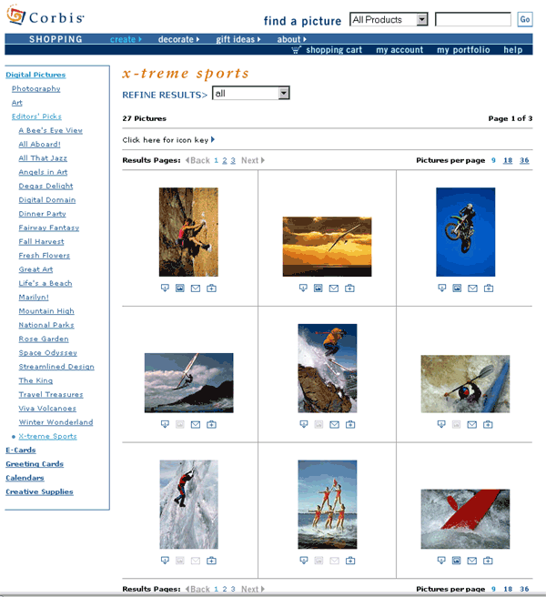

Appendix B (Contd.)

PictureQuest
http://www.picturequest.com

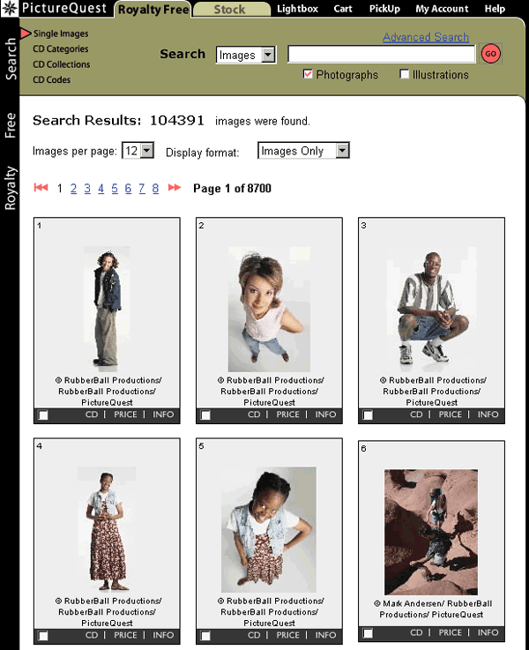

Appendix B (Contd.)

SciencePhoto
http://www.sciencephoto.com

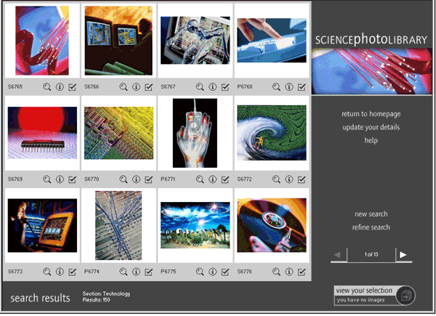

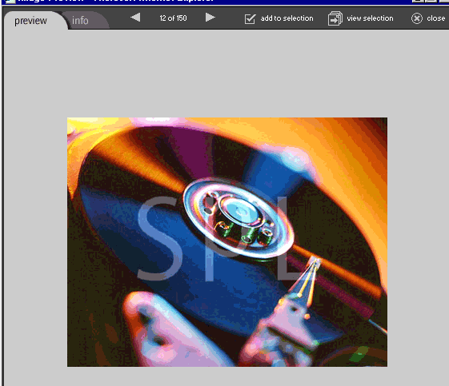

Appendix C : 2nd Category Screenshots

Second Category Screenshots

World Bank
http://worldbank.emotions.com
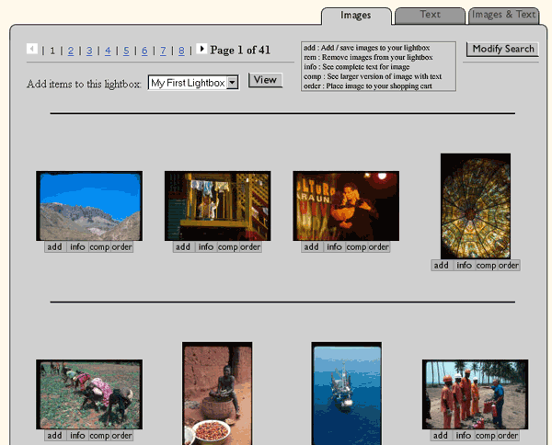
Appendix C (Contd.)

NOAA
http://photolib.noaa.gov
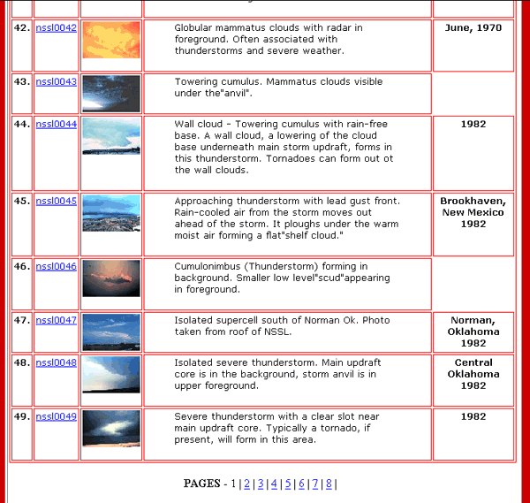
Appendix C (Contd.)

Library of Congress
http://memory.loc.gov

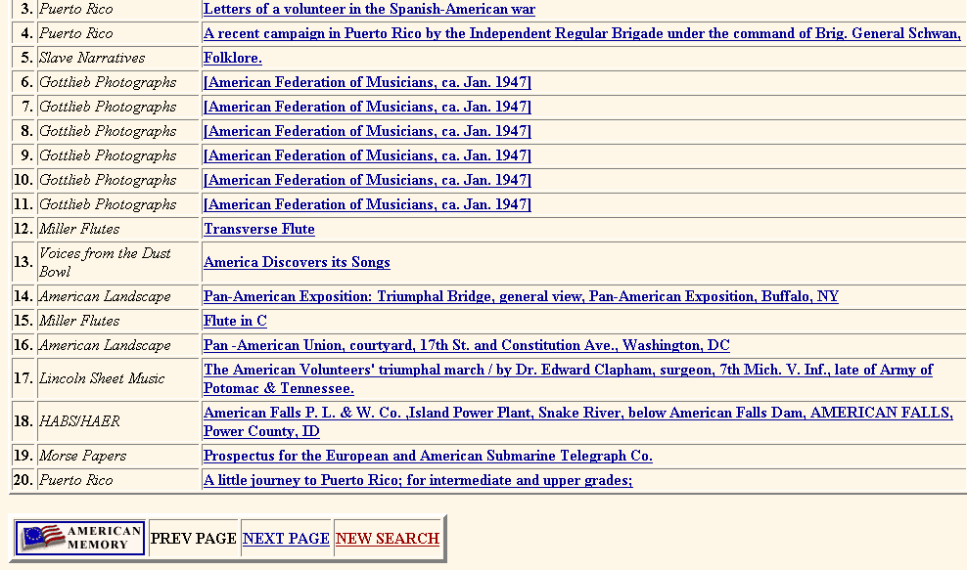

Appendix D : 3rd Category Screenshots

Third Category Screenshots

Lycos
http://multimedia.lycos.com

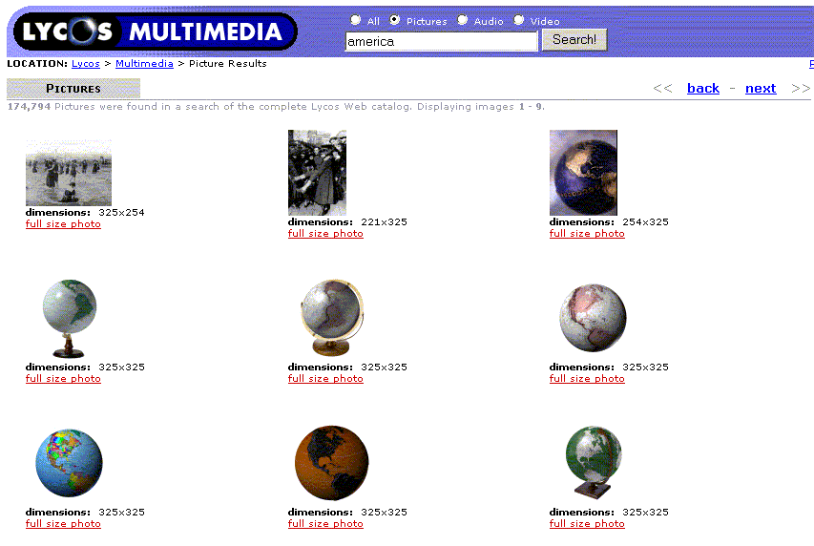

Appendix D (Contd.)

Yahoo!
http://photos.yahoo.com

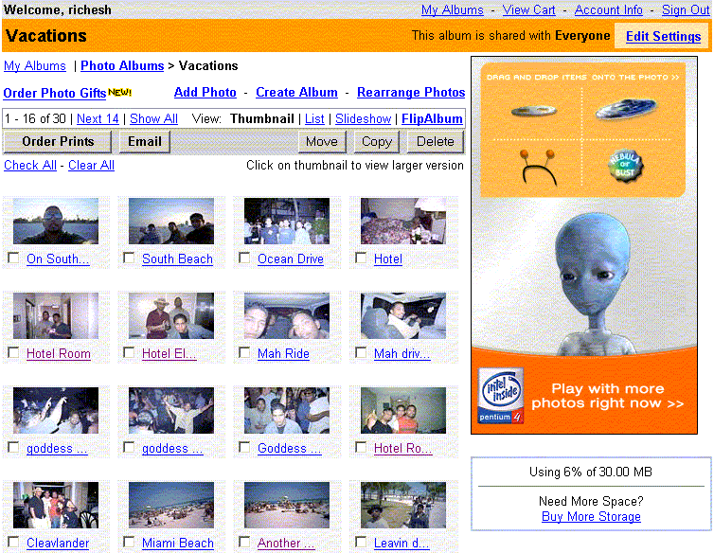
Appendix D (Contd.)

Altavista
http://www.altavista.com

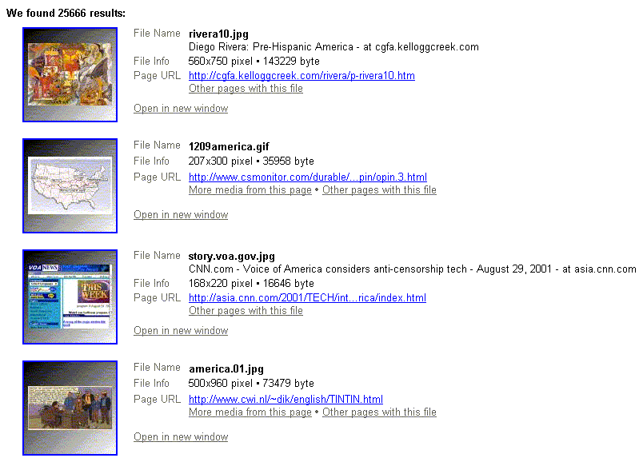

Appendix E : System Flow Chart

Appendix F : Web-siteStarter Screenshots

