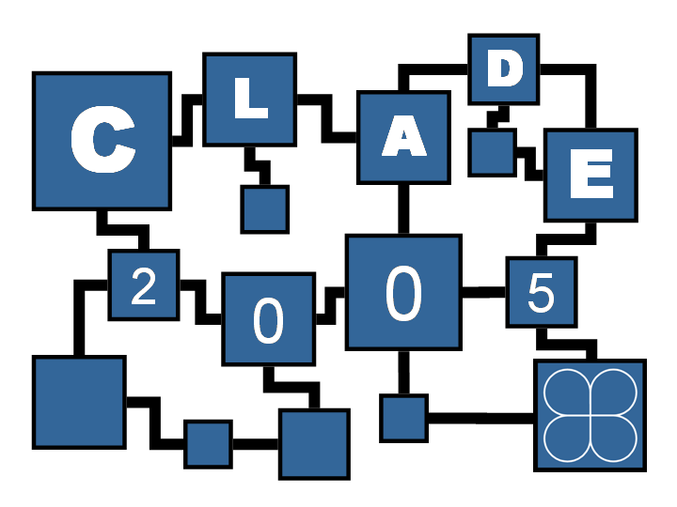 | Challenges of Large Applications in Distributed Environments (CLADE)  Call For Papers (PDF)
In conjunction with the 14th International Symposium on High Performance Distributed Computing (HPDC-14)
Research Triangle Park, NC, July 2005
http://www.cs.umd.edu/CLADE2005/
Advances in networking, high-end computers, large data stores and middleware capabilities are ushering in a new era of large scale, distributed applications, which dynamically marshal resources across a heterogeneous, distributed environment. Along with these opportunities come new challenges. The goal of this workshop is to encourage innovation by addressing the complex issues that arise in large-scale applications of distributed computation, and to promote the development of innovative applications that effectively use distributed resources and adapt to a wide range of heterogeneity and dynamics in space and time. This includes development, deployment, management and evaluations of large scale applications in science, engineering, medicine, business, economics, education, and other disciplines, on Grids and other distributed heterogeneous and dynamic computing environments. Issues related to irregularity of applications and algorithms in space and time, variability in programming environments, heterogeneity of software and hardware platforms, dynamics, ad hoc behaviors and unreliability of execution environments, etc., in the context of these applications are of particular interest.

SPONSORS
IEEE & IEEE Computer Society
U.S. Department of Energy, Office of Science
National Science Foundation

GENERAL CHAIR
Raymond Bair, Argonne National Laboratory, USA

PROGRAM CHAIR
Alan Sussman, University of Maryland, USA
(als@cs.umd.edu)

STEERING COMMITTEE
Raymond Bair, ANL, USA
Ioana Banicescu, Mississippi State University, USA
Francine Berman, Univ. of California, San Diego, USA
Jack Dongarra, Univ. of Tennessee, Knoxville, USA
Salim Hariri, University of Arizona, USA
Manish Parashar, Rutgers University, USA
Viktor Prasanna, Univ. of Southern California, USA
Joel Saltz, Ohio State University, USA
Edward Seidel, Louisiana State University, USA

PROGRAM COMMITTEE

Henrique Andrade, IBM TJ Watson Research Lab, USA
Mark Baker, Univ. of Portsmouth, UK
David Bernholdt, Oak Ridge National Laboratory, USA
Rupak Biswas, NASA Ames Research Center, USA
Randy Bramley, Indiana Univ., USA
Umit Catalyurek, Ohio State Univ., USA
Jose Cunha, CITI, Univ. Nova de Lisboa, Portugal
Ewa Deelman, Univ. of Southern California. ISI, USA
Frédéric Desprez, INRIA Rhône-Alpes, France
Lori Freitag Diachin, Lawrence Livermore National Laboratory, USA
Afonso Ferreira, CNRS, France & COST Office, Belgium
Michael Gerndt, Munich Technical Univ., Germany
Tahsin Kurc, Ohio State Univ., USA
Mario Lauria, Ohioi State Univ., USA
David Lowenthal, Univ. Georgia, USA
Malika Mahoui, IUPUI, USA
Jun Ni, University of Iowa, USA
Steve Parker, Univ. of Utah, USA
Marlon Pierce, Indiana Univ., USA
Omer Rana, Cardiff Univ., UK
Thomas Rauber, Univ. of Bayreuth, Germany
David Skillicorn, Queen's Univ., Canada
Jon Weissman, Univ. of Minnesota, USA
Xiadong Zhang, National Science Foundation, USA
Albert Zomaya, Univ. of Sydney, Australia

IMPORTANT DATES
- Submission deadline: February 24, 2005
- Notification of acceptance: April 12, 2005
- Final Manuscript due: May 03, 2005
- Workshop: July 24, 2005

This workshop promotes the exchange of ideas, information, and novel developments among universities, federal laboratories, and industry. It fosters multidisciplinary collaborative solutions to issues arising in large-scale distributed applications. Topics of interest to this workshop include (but are not limited to) applications that illustrate advances in the following areas:

- Very large-scale distributed applications
- Autonomic applications and runtime systems
- Application-specific portals in distributed environments
- Distributed problem-solving environments
- Distributed, collaborative science applications
- Heterogeneous spatial and temporal applications, e.g., with heterogeneous characteristics in time, space and domain
- Distributed, multidimensional, dynamically adaptive applications
- Applications of new theories and tools for constructing adaptive software systems
- Variable granularity environments
- Examples of distributed applications benefiting from advances in
  - Resource management, dynamic scheduling or load balancing in heterogeneous environments
  - Runtime support for intelligent, adaptive systems
  - Programming models for heterogeneous and dynamic computation
  - Portability, quality of service, or fault-tolerance in cluster and grid computation
  - Performance analysis, evaluation and prediction of adaptive systems

PAPER SUBMISSIONS
CLADE 2005 invites authors to submit original and unpublished work. Please submit full papers (10 pages maximum, IEEE CS format). Electronic submission is strongly encouraged. Hard copies will be accepted only if electronic submission is not possible. Submission implies the willingness of at least one of the authors to register at the workshop and present the paper. Any questions concerning hardcopy submissions or any other issues may be directed to the Program Chair.

PUBLICATION
The workshop proceedings will be published by IEEE Computer Society Press and distributed at the conference.

FURTHER INFORMATION
For further information please contact the Program Chair: Alan Sussman, <als@cs.umd.edu>

