- 10 points Prove that convolving a 1-D signal twice with a Gaussian kernel is equivalent to convolving the signal with a single Gaussian kernel with a larger standard deviation. (Hint: Make use of the identity:
$\int_{−∞}^{∞}{e^{−\frac{1}{2}{\text{Ax}}^{2}+\text{Zx}}\text{dx}}=\sqrt{\frac{2π}{A}}e^{\frac{Z^{2}}{2A}}$with A>0.)
Proof:

We know that convolving twice with two filters is convenient as convolving the two filters first to get a new filter, and then convolve the signal with the new filter. So we only need to prove that the convolution of a Gaussian kernel with another Gaussian kernel is also a Gaussian kernel.

Suppose the two 1D Gaussian kernels $g_{1}(x)$,$g_{2}(x)$are with standard deviations $σ_{1}$,$σ_{2}$, then their convolution is
$\int_{−∞}^{∞}{g_{1}(u)g_{2}(x−u)\text{du}}$
$$=\int_{−∞}^{∞}{\frac{1}{\sqrt{2π}σ_{1}}\text{exp}}$$
$$=\frac{1}{2{\text{πσ}}_{1}σ_{2}}\int_{−∞}^{∞}{\text{exp}}$$
$\begin{aligned}=\frac{1}{2{\text{πσ}}_{1}σ_{2}}\int_{−∞}^{∞}{\text{exp}\left\{−\frac{σ_{2^{2}}u^{2}+σ_{1^{2}}(x−u)^{2}}{2σ_{1^{2}}σ_{2^{2}}}\right\}\text{du}} \\ \frac{1}{2{\text{πσ}}_{1}σ_{2}}\int_{−∞}^{∞}{\text{exp}\left\{−\frac{(σ_{1^{2}}+σ_{2^{2}})u^{2}+σ_{1^{2}}x^{2}−2σ_{1^{2}}\text{xu}}{2σ_{1^{2}}σ_{2^{2}}}\right\}\text{du}} \\ \frac{1}{2{\text{πσ}}_{1}σ_{2}}\left\{\int_{−∞}^{∞}{\text{exp}\left\{−\frac{(σ_{1^{2}}+σ_{2^{2}})u^{2}−2σ_{1^{2}}\text{xu}}{2σ_{1^{2}}σ_{2^{2}}}\right\}\text{du}}+\int_{−∞}^{∞}{\text{exp}\left\{−\frac{σ_{1^{2}}x^{2}}{2σ_{1^{2}}σ_{2^{2}}}\right\}\text{du}}\right\} \\ \frac{1}{2{\text{πσ}}_{1}σ_{2}} \\ \end{aligned}$
Let
$A=(σ_{1^{2}}+σ_{2^{2}})/{σ_{1^{2}}}σ_{2^{2}}>0$ and
$Z=x/{σ_{2^{2}}}$

Then
$\int_{−∞}^{∞}{g_{1}(u)g_{2}(x−u)\text{du}}$ $\begin{aligned}=\frac{1}{2{\text{πσ}}_{1}σ_{2}}\text{exp}\left\{−\frac{x^{2}}{2σ_{2^{2}}}\right\}\sqrt{\frac{2π}{A}}\text{exp}\left\{\frac{Z^{2}}{2A}\right\} \\ \frac{1}{2{\text{πσ}}_{1}σ_{2}}\text{exp}\left\{−\frac{x^{2}}{2σ_{2^{2}}}\right\}\sqrt{\frac{2π}{(σ_{1^{2}}+σ_{2^{2}})/{σ_{1^{2}}}σ_{2^{2}}}}\text{exp}\left\{\frac{(x/{σ_{2^{2}}})^{2}}{2(σ_{1^{2}}+σ_{2^{2}})/{σ_{1^{2}}}σ_{2^{2}}}\right\} \\ \frac{1}{\sqrt{2π}\sqrt{σ_{1^{2}}+σ_{2^{2}}}}\text{exp}\left\{\frac{x^{2}}{2(σ_{1^{2}}+σ_{2^{2}}){σ_{2^{2}}}/{σ_{1^{2}}}}−\frac{x^{2}}{2σ_{2^{2}}}\right\} \\ \frac{1}{\sqrt{2π}\sqrt{σ_{1^{2}}+σ_{2^{2}}}}\text{exp}\left\{−\frac{x^{2}}{2(σ_{1^{2}}+σ_{2^{2}})}\right\}\end{aligned}$
So the result is also a Gaussian function with standard deviation $\sqrt{σ_{1^{2}}+σ_{2^{2}}}$, which is larger than both of the two deviations of the two Gaussian filters.

Furthermore when $g_{1}$ and $g_{2}$ are same Gaussian kernels, that is, $σ_{1}=σ_{2}$, we have
$\int_{−∞}^{∞}{g_{1}(u)g_{2}(x−u)\text{du}}=\frac{1}{\sqrt{2π}\sqrt{2}σ}\text{exp}\left\{−\frac{x^{2}}{2(\sqrt{2}σ)^{2}}\right\}$
The standard deviation now is $\sqrt{2}σ$.

- 1D Edge Detection
- 10 points Write a function to produce a Gaussian kernel, in which the standard deviation, sigma, is a parameter. Make sure the kernel is big enough to capture 99% of the area of the Gaussian. Plot it for sigma=2. Turn in the plot.

Solution:
Matlab codes Gaussian.m, hwk2a.m, please refer to the appendix for the printed code.

Output result is following image:

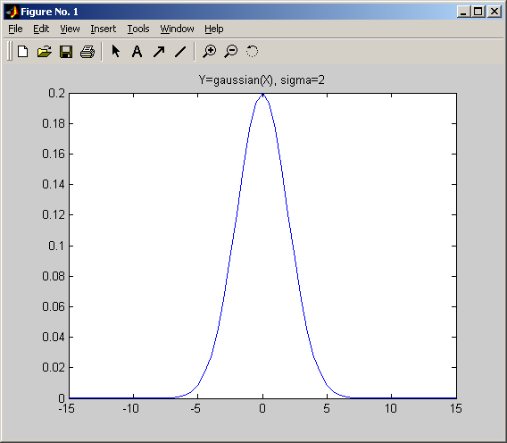

- 10 points Write a function to convolve a signal with a kernel in 1D. Test it by convolving a Gaussian with itself 2 and 3 times. Plot both. Turn in the plots.

Solution:
Matlab codes: Convolve1D.m, hwk2b.m, refer to appendix please.

Output result is following image:

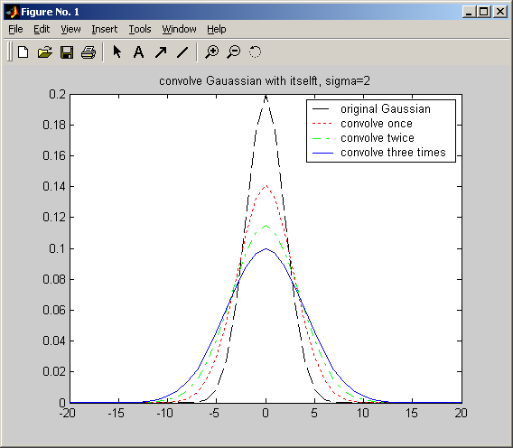

- 20 points Write a 1D edge detector. This should take 2 parameters, the amount of smoothing and a threshold on the strength of the edge. Test it by finding the edges in the following 1D image.
I = [zeros(1,50), .9*ones(1,10), zeros(1,10), .6*ones(1,40), zeros(1,50)].

Solution:

Matlab codes: EdgeDetect1D.m, hwk2c.m, refer to appendix please.

Output result is following image:

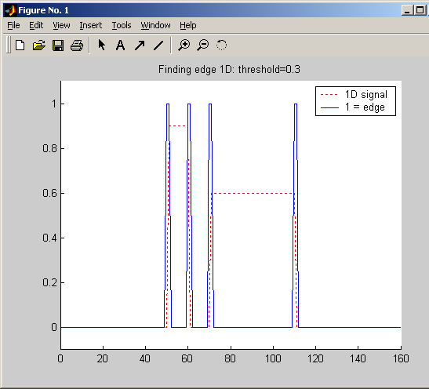

d) 20 points Use a very low threshold, which should work since there’s no noise. For sigma = .5, 1, 1.5, 2, 2.5, 3, … 25 determine the location of the edges in image I (from part 2c). Plot them in a 2D picture, where each row shows the edges detected for a different sigma. Turn in the plot.

Solution:

Matlab codes: hwk2d.m, refer to appendix please.

Output result is following image. The output shows that when the sigma is large, no edges can be detected.

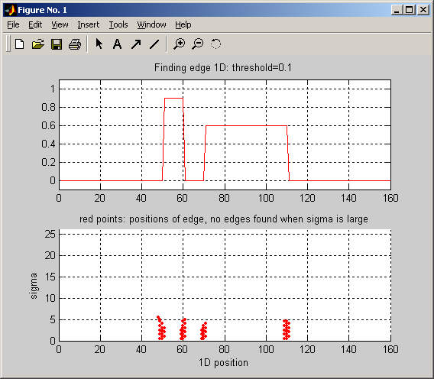

e) 20 points Form and turn in the same plot, this time adding Gaussian noise to the image with a standard deviation of 1 (see function randn).
I = [zeros(1,50), 9*ones(1,10), zeros(1,10), 3*ones(1,40), zeros(1,50)].

Solution:

Matlab codes: hwk2d.m, refer to appendix please.

Output result is following image.
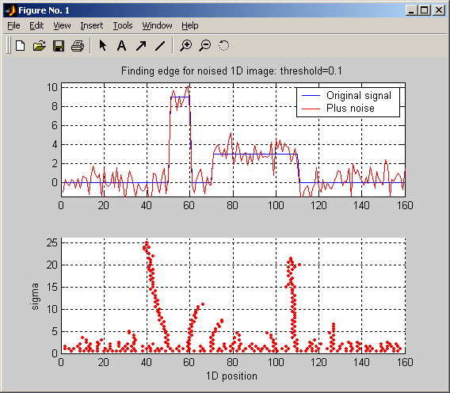

- 10 points Download two images from the internet, or take two images yourself if you have a digital camera. The first image should be one you think will be easy to find edges in, the second image should be one that seems hard. Choose a black and white image, or convert it with rgb2gray. For each image: Run the canny edge detectors, with the default parameters: edge(I,'canny',[.02,.1],1). Then play with the parameters until you get the best results you can. On this final, best, version, circle and label two places where you think the edge detector made a mistake, if it did. Explain why you think it got the wrong answer.

For each image, turn in the image, the edges found using default parameters, and edges with the best hand-chosen parameters with points labeled. List the parameters you used. Also turn in your explanation for why any failures occurred.

Solution:

Matlab codes: hwk3.m, refer to appendix please.

Matlab output result is following image.

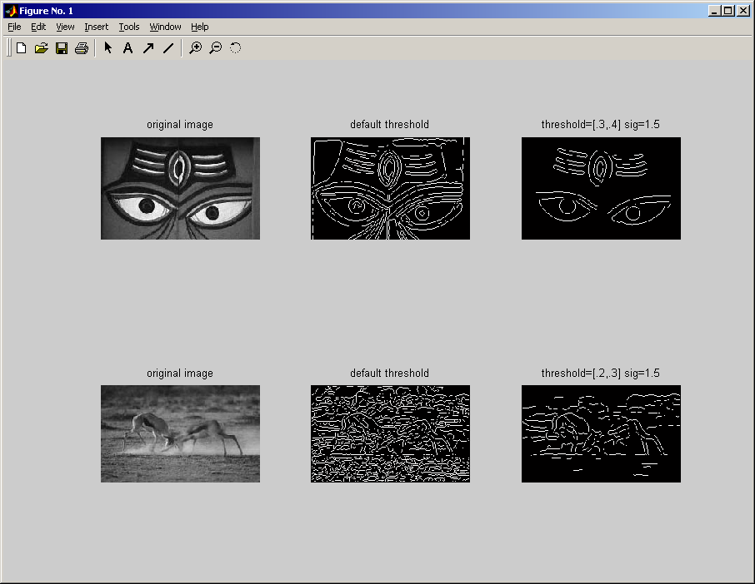

Image 1 (1.jpg): easy for edge detection.
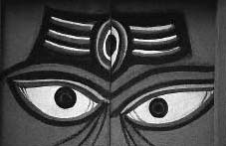
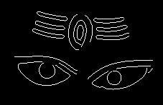
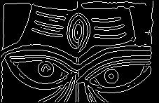

1.jpg 1E.jpg 1Eo.jpg
The left one is the original image, the center one is the result of canny edge detecting using the default threshold. The right one is the “optimal” one with low threshold=0.3, high threshold=0.4, and sigma=1.5.
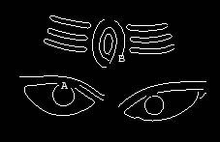
Failures:
A: the sigma is larger so the edge is blurred too much, and at the same time the threshold is large.
B: the contrast of the edge is not so brilliant, so after smooth it failed to be detected.

Image 2 (2.jpg): hard for edge detection.

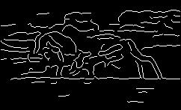
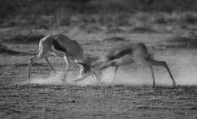
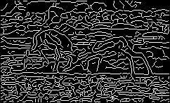

2.jpg 2E.jpg 2Eo.jpg

The left one is the original image, the center one is the result of canny edge detecting using the default threshold. The right one is the “optimal” one with low threshold=0.3, high threshold=0.4, and sigma=1.5.
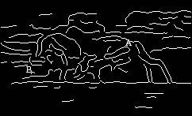
Failures:
A: The edge is not so clear, the foreground and background have similar intensity.
B: the edge is not so sharp. So after smooth, it failed to be detected.
4) 20 points Challenge problem (this is optional for extra credit): Consider a 1D box kernel of width 2m, and height 1. Call this kernel, k. k must lie entirely in the interval 0 to 2pi, so assume m<pi Write k as a linear combination of the basis elements:
$$\frac{\text{cos}θ}{\left\|\text{cos}θ\right\|},\frac{\text{sin}θ}{\left\|\text{sin}θ\right\|},\frac{\text{cos}2θ}{\left\|\text{cos}2θ\right\|},\frac{\text{sin}2θ}{\left\|\text{sin}2θ\right\|},…$$

Hint: you are free to place k anywhere in the interval 0 to 2pi. Put it somewhere that will make your life easier.

Solution:

First, it’s easy to see following three properties,
$\int_{0}^{2π}{\text{cos}(\text{nx})\text{cos}(\text{mx})\text{dx}}=\frac{1}{2}\int_{0}^{2π}{\text{cos}((n+m)x)+\text{cos}((n−m)x)\text{dx}}$
$=\begin{aligned}\left\{\frac{1}{2}\int_{0}^{2π}{\text{cos}((n+m)x)\text{dx}}+\frac{1}{2}\int_{0}^{2π}{\text{cos}(0∗x)\text{dx}=0+\frac{1}{2}2π=π} | \right.\end{aligned}$ $\begin{aligned}n=m \\ \\ n≠m\end{aligned}$

$$\int_{0}^{2π}{\text{sin}(\text{nx})\text{sin}(\text{mx})\text{dx}}=\frac{1}{2}\int_{0}^{2π}{\text{cos}((n−m)x)−\text{cos}((n+m)x)\text{dx}}$$
$=\begin{aligned}\left\{\frac{1}{2}\int_{0}^{2π}{\text{cos}(0∗x)\text{dx}}−\frac{1}{2}\int_{0}^{2π}{\text{cos}((n+m)x)\text{dx}}=\frac{1}{2}2π−0=π | \right.\end{aligned}$ $\begin{aligned}n=m \\ \\ n≠m\end{aligned}$

$$\int_{0}^{2π}{\text{cos}(\text{nx})\text{sin}(\text{mx})\text{dx}}=\frac{1}{2}\int_{0}^{2π}{\text{sin}((n+m)x)−\text{sin}((n−m)x)\text{dx}}$$
$$=\frac{1}{2}(\int_{0}^{2π}{\text{sin}((n+m)x)\text{dx}}−\int_{0}^{2π}{\text{sin}((n−m)x)\text{dx}})=\frac{1}{2}(0−0)=0$$
Then, based on this we have
$||\text{cos}nθ||=\sqrt{\int_{0}^{2π}{{\text{cos}}^{2}nθ}}=\sqrt{π}$
$||\text{sin}nθ||=\sqrt{\int_{0}^{2π}{{\text{sin}}^{2}nθ}}=\sqrt{π}$
Next let’s consider about the box kernel

$κ(x)=\begin{aligned}\left\{1 | \right.\end{aligned}$ $\begin{aligned}π−m<x<π+m \\ \text{otherwise}\end{aligned}$

Write the kernel as
$$κ(x)=\sum_{n=1}^{∞}{a_{n}\frac{\text{cos}\text{nx}}{||\text{cos}\text{nx}||}}+\sum_{n=1}^{∞}{b_{n}\frac{\text{sin}x}{||\text{sin}\text{nx}||}}$$

So what we need compute $a_{n},b_{n}$, for $n=1,2,\text{.}\text{.}\text{.}$
While we have
$\int_{0}^{2π}{\left\{κ(x)\text{cos}\text{kx}\right\}\text{dx}}=\int_{0}^{2π}{\left\{(\sum_{n=1}^{∞}{a_{n}\frac{\text{cos}\text{nx}}{||\text{cos}\text{nx}||}}+\sum_{n=1}^{∞}{b_{n}\frac{\text{sin}x}{||\text{sin}\text{nx}||}})\text{cos}\text{kx}\right\}\text{dx}}$
$$=\sum_{n=1}^{∞}{\frac{a_{n}}{||\text{cos}\text{nx}||}\int_{0}^{2π}{\left\{\text{cos}\text{nx}\text{cos}\text{kx}\right\}\text{dx}}}+\sum_{n=1}^{∞}{\frac{b_{n}}{||\text{sin}\text{nx}||}\int_{0}^{2π}{\left\{\text{sin}\text{nx}\text{cos}\text{kx}\right\}\text{dx}}}$$
$$=\sum_{n=1}^{∞}{\frac{a_{n}}{||\text{cos}\text{nx}||}×\text{πδ}(n,k)}+\sum_{n=1}^{∞}{\frac{b_{n}}{||\text{sin}\text{nx}||}×0}$$
$$=\frac{a_{k}}{||\text{cos}\text{kx}||}×π=\sqrt{π}a_{k}$$
Where
$δ(n,k)=\begin{aligned}\left\{1 | \right.\end{aligned}$ $\begin{aligned}n=k \\ \text{otherwise}\end{aligned}$
So we get
$a_{k}=\frac{1}{\sqrt{π}}\int_{0}^{2π}{\left\{κ(x)\text{cos}\text{kx}\right\}\text{dx}}$
$=\frac{1}{\sqrt{π}}\int_{π−m}^{π+m}{\text{cos}\text{kxdx}}=\frac{1}{\sqrt{π}}\int_{−m}^{m}{\text{cos}\text{kxdx}=}\frac{2}{\sqrt{π}}\int_{0}^{m}{\text{cos}\text{kxdx}}\frac{2}{k\sqrt{π}}\int_{0}^{m}{\left\{\text{cos}\text{kx}\right\}d(\text{kx})}$
$=\frac{2}{k\sqrt{π}}\text{sin}\text{kx}|_{x=0}^{m}=\frac{2}{k\sqrt{π}}\text{sin}\text{km}$
Similarly we get
$b_{k}=\frac{1}{\sqrt{π}}\int_{0}^{2π}{\left\{κ(x)\text{sin}\text{kx}\right\}\text{dx}}$
$=\frac{1}{\sqrt{π}}\int_{π−m}^{π+m}{\text{sin}\text{kxdx}}=\frac{1}{\sqrt{π}}\int_{−m}^{m}{\text{sin}\text{kxdx}=}\frac{2}{\sqrt{π}}×0=0$

So
$κ(x)=\sum_{n=1}^{∞}{a_{n}\frac{\text{cos}\text{nx}}{||\text{cos}\text{nx}||}}+\sum_{n=1}^{∞}{b_{n}\frac{\text{sin}x}{||\text{sin}\text{nx}||}}=\sum_{n=1}^{∞}{\frac{2}{n\sqrt{π}}\text{sin}(\text{nm})\frac{\text{cos}\text{nx}}{||\text{cos}\text{nx}||}}$ #
Appendix 1: code for problem 2

File Gaussian.m

function Y = Gaussian(X, sigma, mi)
if nargin<3 mi = 0; end
Y = (1/(sqrt(2*pi)*sigma)) * exp( - ((X-mi)/sigma).^2/2 );

File hwk2a.m

% homework problem 2, Gaussian function testing

X = -15:.5:15;
Y = Gaussian(X, 2);
plot(X,Y);
title('Y=gaussian(X), sigma=2');

File Convolve1D.m

% Convolve1D.m function to convolve a signal with a kernel in 1D.

function dRes = Convolve1D(signal, kernel)

sLen = length(signal);
kLen = length(kernel);

sigSZ = size(signal);
if sigSZ(1) == 1 dRes = zeros(1,sLen+kLen-1);
else dRes = zeros(sLen+kLen-1,1);
end

for x=1:kLen
dRes(x:x+sLen-1) = dRes(x:x+sLen-1) + kernel(x)*signal;
end

File hwk2b.m

% hwk2b
% Write a function to convolve a signal with a kernel in 1D.
% Test it by convolving a Gaussian with itself 2 and 3 times. Plot both. Turn in the plots.

clear all;

X = -20:1:20;
Y = Gaussian(X, 2);
dMargin = floor(length(X)/2);
Y1 = Convolve1D(Y,Y);
Y1 = Y1(dMargin+1:dMargin+length(X));
Y2 = Convolve1D(Y1,Y);
Y2 = Y2(dMargin+1:dMargin+length(X));
Y3 = Convolve1D(Y2,Y);
Y3 = Y3(dMargin+1:dMargin+length(X));

plot(X,Y,'k--', X,Y1,'r:', X,Y2,'g-.', X,Y3,'b-');
legend('original Gaussian', 'convolve once', 'convolve twice', 'convolve three times');
Title('convolve Gauassian with itselft, sigma=2');

File EdgeDetect1D.m

% EdgeDetect1D.m
% 1D edge detector. Take 2 parameters, the amount of smoothing
% and a threshold on the strength of the edge
%
% returns a binary image BW of the same size as I, with 1's where
% the function finds edges in I and 0's elsewhere.

function imRes = EdgeDetect1D(im1D, sigma, threshold)

X = ceil(-3*sigma:3*sigma);
fGau = Gaussian(X, sigma);
fGra = [1, 0, -1];

dMargin = 1;
fDoG = Convolve1D(fGau,fGra);
fDoG = fDoG(dMargin+1:dMargin+length(X));

dMargin = floor(length(fDoG)/2);
imRes = Convolve1D(im1D, fDoG);
imRes = imRes(dMargin+1:dMargin+length(im1D));

resLen = length(imRes);
imRes = abs(imRes);
peaks = [0, (imRes(2:resLen-1)> imRes(1:resLen-2) & imRes(2:resLen-1)>=imRes(3:resLen)) | ...
(imRes(2:resLen-1)>=imRes(1:resLen-2) & imRes(2:resLen-1)> imRes(3:resLen)), 0];
imRes = peaks.*imRes;
imRes = imRes > threshold;

File hwk2c.m

% hwk2c.m. Testing the result of running EdgeDetect1D.
clear all;

I=[zeros(1,50),.9*ones(1,10),zeros(1,10),.6*ones(1,40),zeros(1,50)];
sigma = 1;
threshold = .3;
imEdge = EdgeDetect1D(I, sigma, threshold);

figure(1); clf, hold on;
plot(1:length(I), I,'r:', 1:length(I),imEdge,'b-');
legend('1D signal', '1 = edge', 1);
axis([0,160,-.1,1.1]);
Title('Finding edge 1D: threshold=0.3');

File hwk2d.m

% hwk2d.m
clear all;

I=[zeros(1,50),.9*ones(1,10),zeros(1,10),.6*ones(1,40),zeros(1,50)];

figure(1); clf, hold on;
subplot(2,1,1); plot(1:length(I), I,'r');
axis([0,160,-.1,1.1]); grid on;
Title('Finding edge 1D: threshold=0.1');

subplot(2,1,2); hold on;
threshold = .1;
for sigma=.5:.5:25
imEdge = EdgeDetect1D(I, sigma, threshold);
for x=1:length(imEdge)
if imEdge(x)>0.99 % 1 means the edge
plot(x,sigma,'.r');
end
end
end
axis([0,160,0,26]); grid on;
xlabel('1D position');
ylabel('sigma');
Title('red points: positions of edge, no edges found when sigma is large');

File hwk2e.m

% hwk2e.m
clear all;

IOld = [zeros(1,50), 9*ones(1,10), zeros(1,10), 3*ones(1,40), zeros(1,50)];
I = IOld + randn(1,length(IOld));

figure(1); clf, hold on;
subplot(2,1,1);
plot(1:length(IOld), IOld,'b-', 1:length(I), I,'r-');
legend('Original signal', 'Plus noise');
axis([0,160,-1.5,10.5]); grid on;
Title('Finding edge for noised 1D image: threshold=0.1');

subplot(2,1,2); hold on;
threshold = .1;
for sigma=.5:.5:25
imEdge = EdgeDetect1D(I, sigma, threshold);
for x=1:length(imEdge)
if imEdge(x)>0.99 % 1 means the edge
plot(x,sigma,'.r');
end
end
end
axis([0,160,0,26]); grid on;
xlabel('1D position');
ylabel('sigma');

Appendix 2: code for problem 3

File hwk3.m

% hwk3.m, homework problem #3
clear all;

I = imread('1.jpg');
E1 = edge(I, 'canny', [.02, .1], 1);
E1o = edge(I, 'canny', [.3, .4], 1.5);
imwrite(E1,'1E.jpg', 'JPEG');
imwrite(E1o,'1Eo.jpg', 'JPEG');
figure(1); clf; hold on;
subplot(2,3,1); imshow(I); title('original image');
subplot(2,3,2); imshow(E1); title('default threshold');
subplot(2,3,3); imshow(E1o); title('threshold=[.3,.4] sig=1.5');

I = imread('2.jpg');
E1 = edge(I, 'canny', [.02, .1], 1);
E1o = edge(I, 'canny', [.20, .3], 1.5);
imwrite(E1,'2E.jpg', 'JPEG');
imwrite(E1o,'2Eo.jpg', 'JPEG');
subplot(2,3,4); imshow(I); title('original image');
subplot(2,3,5); imshow(E1); title('default threshold');
subplot(2,3,6); imshow(E1o); title('threshold=[.2,.3] sig=1.5');

