1.
a)

4 | 0.04 | 0.03 | 0.02 | 0.01 | 0.02
3 | 0.03 | 0.02 | 0.01 | 0.02 | 0.03
2 | 0.02 | 0.01 | 0.02 | 0.01 | 0.02
1 | 0.01 | 0 | 0.01 | 0.02 | 0.03
0 | 0 | 0.01 | 0.02 | 0.03 | 0.04
 | 0 | 1 | 2 | 3 | 4

4 | 1 or 2 | 2 | 1 | 1 or 3
3 | 2 | 1 | 2 or 3 | 2 or 3
2 | 1 or 2 | 2 or 3 | 1 | 1 or 3
1 | 1 | 3 | 3 | 1 or 3
 | 1 | 2 | 3 | 4

[0] -> [X 0] -> [-1 X 0] -> [0 -1 X 0]
-> [-1 -1 X 0]
-> [0] -> [1 0] -> [X 1 0] -> [0 X 1 0]
[X]-> [-1 X] -> [-1 -1 X] -> [0 -1 -1 X]
-> [-1 -1 -1 X]

b)

function [c, i] = extend_match (x, y, c1, c2, c3, oc)
[c, i] = min([c1 + oc, c2 + oc, sqrt((x-y)^2) + c3]) ;

Results)
extend_match(1,1,3.7,3.9,3.5,0.01)
ans = 3.5000

extend_match(1,0,3.7,3.9,3.5,0.01)
ans = 3.7100

c)

function d = stereo_1d(v1, v2, oc)
d1 = length(v1) ;
d2 = length(v2) ;

d = [] ;
CM = zeros(d1+1, d2+1) ; % For containing the matching cost
MM = zeros(d1, d2) ; % For reconstructing the optimum path

for i = 0 : d1
for j = 0 : d2
if i == 0 || j == 0
CM(i+1,j+1) = oc * max([i j]) ;
else
[CM(i+1,j+1) MM(i, j)] = ...
extend_match(v1(i), v2(j), CM(i, j+1), CM(i+1, j), CM(i, j), oc) ;
end
end
end

i = d1 ; j = d2 ;
disparity = 0 ;

while ( i ~= 0 && j ~= 0 )
switch MM(i,j)
case 1 ,
disparity = disparity - 1 ;
d = [' X ' d] ;
i = i - 1 ;
case 2 ,
disparity = disparity + 1 ;
j = j - 1 ;
case 3 ,
if disparity < 0
d = [' -' char('0' + abs(disparity)) ' ' d] ;
else
d = [' ' char('0' + disparity) ' ' d] ;
end
i = i -1 ; j = j -1 ;
otherwise,
sprintf('\nError occured during computation.\n') ;
end
end

for j = 1 : i
d = [ d 'X'] ;
end

Results)
v1 = [1 0 1 1 0 1 1 0 0 1 1 0 1 1 1] ;
v2 = [1 0 1 0 1 0 1 1 0 0 1 1 1 1 1] ;

stereo_1d(v1, v2, 0.01)
ans =
0 0 0 -1 -1 -1 -1 -1 -1 -1 -1 X 0 0 0
d)

function D = stereo_2D(V1, V2, oc)

if size(V1) ~= size(V2)
error('DIM NEQ', 'The dimension of the images are not compatible', size(V1), size(V2)) ;
end

D = [];
[n_rows n_cols] = size(V1)

for i = 1 : n_rows
D = [D ; stereo_1dN(V1(i,:) , V2(i,:), oc, max(size(V1)) * oc * 2)] ;
end

D = (D - min(min(D))) ./ (max(size(V1)) * oc * 2) ;

Results)

e)

function d = stereo_1DF(v1, v2, oc, DL)
d1 = length(v1) ;
d2 = length(v2) ;

d = [] ;
CM = ones(d1+1, d2+1) * max(d1,d2) * oc ; % For containing the matching cost
MM = ones(d1, d2) + 2 ; % For reconstructing the optimum path

for i = 0 : d1
for j = max(0, i - DL) : min(d2, i + DL)
if i == 0 || j == 0
CM(i+1,j+1) = oc * max([i j]) ;
else
[CM(i+1,j+1) MM(i, j)] = ...
extend_match(v1(i), v2(j), CM(i, j+1), CM(i+1, j), CM(i, j), oc) ;
end
end
end

i = d1 ; j = d2 ;
disparity = 0 ;
sprintf('Done part 1') ;

while ( i ~= 0 && j ~= 0 )
switch MM(i,j)
case 1 ,
disparity = disparity - 1 ;
d = [DL+10 d] ;
i = i - 1 ;
case 2 ,
disparity = disparity + 1 ;
j = j - 1 ;
case 3 ,
if disparity > DL
d = [DL+10 d] ;
elseif disparity < -DL
d = [-DL-10 d] ;
else
d = [disparity d] ;
end
i = i -1 ; j = j -1 ;
otherwise,
sprintf('\nError occured during computation.\n') ;
end
end

for j = 1 : i
d = [DL+10 d] ;
end

function D = stereo_2DF(V1, V2, oc)

if size(V1) ~= size(V2)
error('DIM NEQ', 'The dimension of the images are not compatible', size(V1), size(V2)) ;
end

D = [];
[n_rows n_cols] = size(V1) ;

for i = 1 : n_rows
DM = stereo_1DF(V1(i,:) , V2(i,:), oc, 15) ;
D = [D ; DM ] ;
end

D = D - min(min(D)) ;
D = D / max(max(D)) * 255 ;
D = uint8(D) ;

Results)
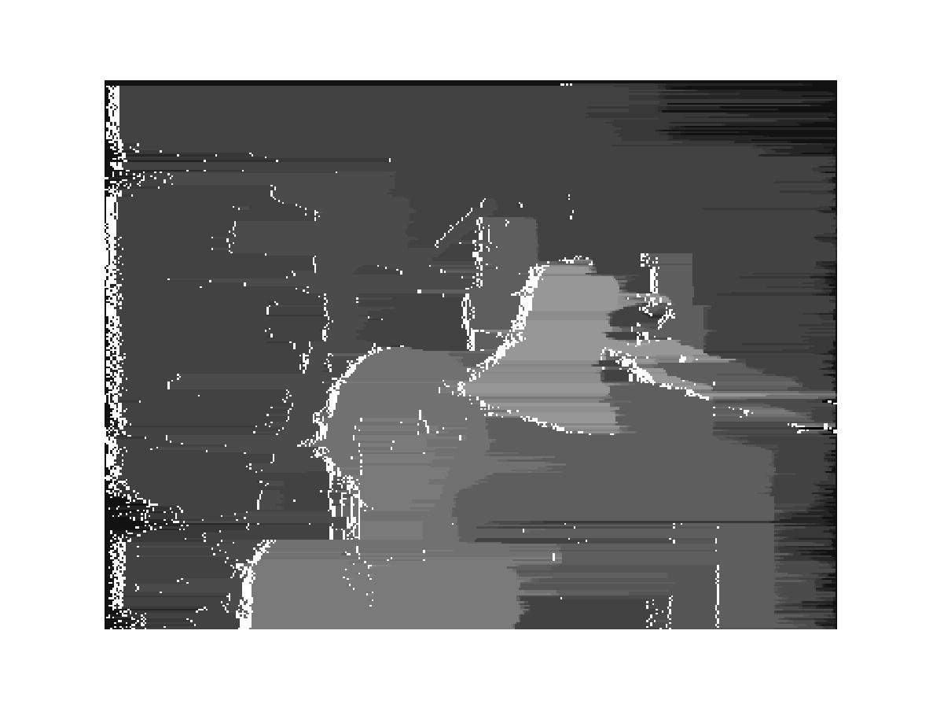
2.
a)
(-9, 0, 1)
(9, 0, 1)
(-10, 0, 0)
(10, 0, 0)
(0, 0, 10)

18 : 20 = z – 1 : z
20z – 20 = 18z
z = 10

Obviously the triangle is an isosceles
triangle. . So

Pt = ( 0 , 0 , 10)

b)

16 : 20 = z-1 : z
20z -20 = 16z
z = 5

By the law of perspective projection
X = fx / z , Y = fy / z where f = 1, z = 5
(-3, 7, 1)
(13, 7, 1)
From the camera 1 coordinate system,
7 = x / 5, x = 35 ( in camera 2 coordinates x = 15 )
7 = y / 5, y = 35 ( in camera 2 coordinates y = 35 )
(-10, 0, 0)
(10, 0, 0)

So in the world coordinates,

x = 35 – 10 = 25 (in case of camera 2, x = 15 + 10 )
y = 35 (in case of camera 2, y = 35 )

(25, 35, 5)

c)
By the equation of x_{w} + z_{w} = 0 and y = 0 ,
The x coordinate of camera 1 coordinates is x = fX/Z, x = (x_{w}+10) / -x_{w}
The x coordinate of camera 2 coordinates is u = fU/Z, u = (x_{w}-10) / -x_{w} = -1 + 10 / x_{w}

Then disparity between them is d = x – u

Finally apply the equation from camera 2 coordinate, 1 / x_{w} = (u+1)/10 ,

d = -20/x_{w} = -20 * (u+1) / 10 = -2 (u + 1)

3.
Dist(O,Q) = (v+1) / sqrt(2)
Line l : (x – z) / sqrt(2) = 0
Q
Dist(P,l) = (v-1) / sqrt(2)

P = (v,1)
R
S

O

Distance from P to line l : (v-1) / sqrt(2)
Distance from O to Q : (v+1) / sqrt(2)
Distance from O to R : 1 / sqrt(2)

By the rule of similar triangle,

Distance from R to S = u = ((v-1) / sqrt(2) ) / (v+1) = (v-1) / (v + 1) * 1/sqrt(2)

[Another solution]
First, think about the coordinate system of the case that the image plane along the line z=1 (the second image). We can have this coordinate system as a reference coordinate system. Then any point (x,z) in that plane would be mapped to v = x/z.

If we observe that point (x,z) at the coordinate system of second image, it looks like the point is rotated around the y-axis –origin is the same- and the degree of the rotation is cosθ = 1/sqrt(2) , sinθ = 1/sqrt(2) , θ = π/4. (Think about the rotation matrix you’ve learned from the class)

Therefore if we transform the (x,z) to the second image coordinate system, we will have x’ = (x-z) / sqrt(2) and z’ = (x+z) / sqrt(2). Then the projection of that point on x + z = 1 is u = x ‘/z ‘ * ( 1/sqrt(2) ) = (x-z) / (x+z) * (1/ sqrt(2)).
v = x / z, x = zv
u = (x-z) / (x+z) * (1/ sqrt(2))
= (v-1) / (v+1) * (1/ sqrt(2))

- when v = 0, the corresponding u is (– 1 / sqrt(2))
b) (v-1) / (v+1) * (1/ sqrt(2))

