1.
a)
function d = SSD(R1, R2)
if size(R1) == size(R2)
d = sum(sum((R1 - R2).^2)) ;
else
d = NaN ;
end

Result)
R1 = [1, 0, 0, 2; 2, 1, 0, 1]; R2 = [0, 2, 1, 1; 1, 0, 0, 1];
SSD(R1,R2)
ans =
9

b)
function A = brute_force_ssd(T,I)

Range = size(I)- size(T) + 1 ;

A = zeros(Range) ;
size_template = size(T) ;

for i = 1 : Range(1)
for j = 1 : Range(2)
A(i,j) = SSD(I( i : i + size_template(1) - 1, j : j + size_template(2) - 1), T);
end
end

Result)
CA=brute_force_ssd(double(imread('template.tiff')), double(imread('Image.tiff'))) ;
Imagesc(CA) ; imshow(CA/max(max(CA))) ;
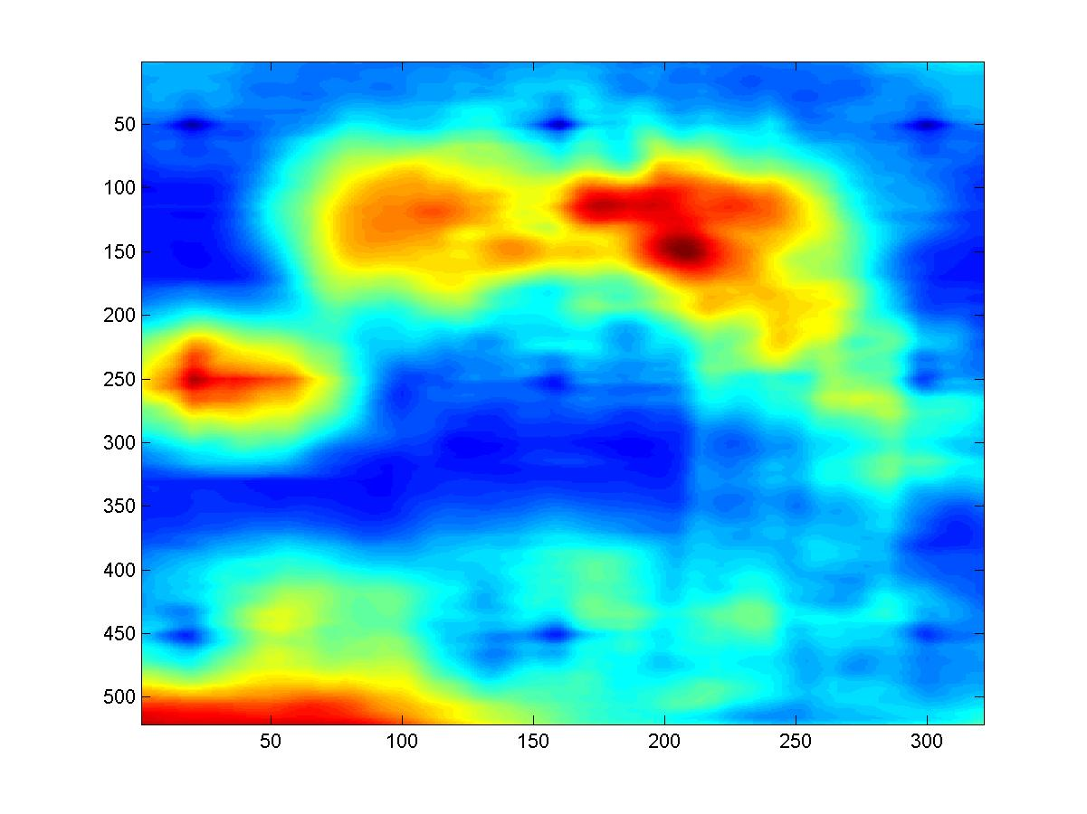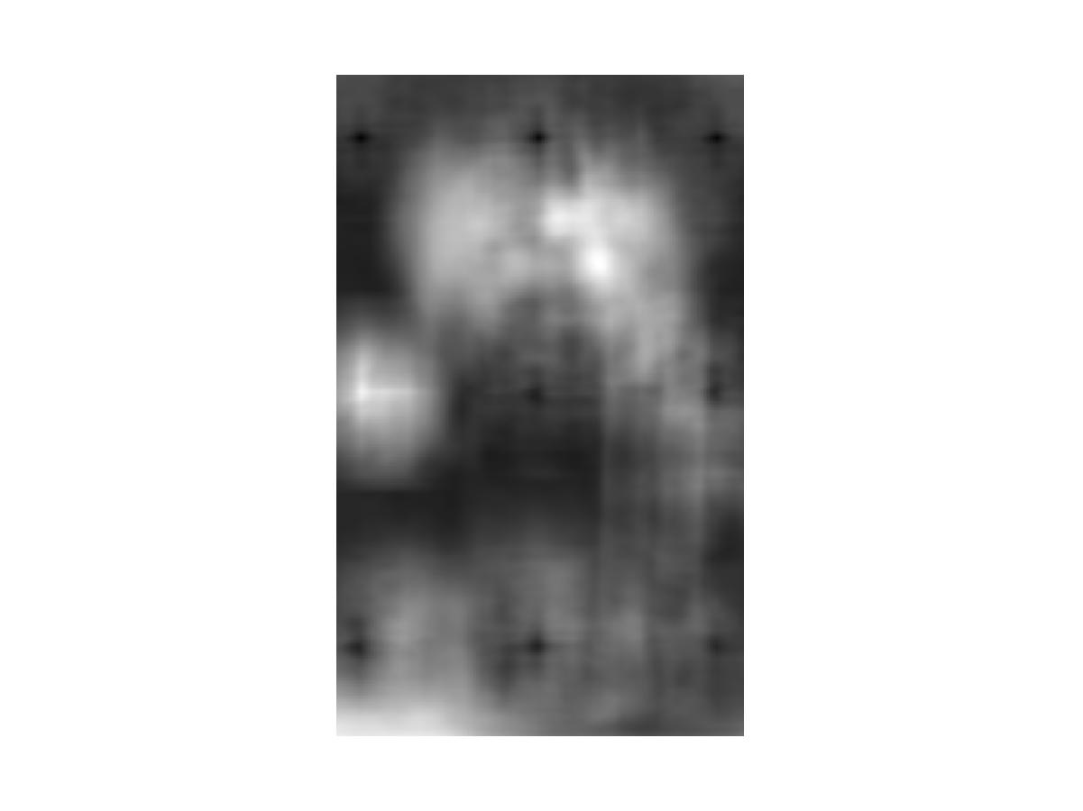
c)
function Cpt = find_best(SSD_value, Npt, Wsize)

[r c] = size(SSD_value) ;
tsize = r * c ;

tDV = [] ;
for i = 1 : r
tDV = [tDV SSD_value(i,:)] ;
end

[V I] = sort(tDV) ;

Fpt = 0; Cpt = [] ; i = 1 ;

while Fpt < Npt && i ~= tsize
row = floor((I(i) - 1) / c) + 1 ;
col = mod(I(i), c) ;

if col == 0
col = c ;
end

valid = true ;

for j = 1 : Fpt
valid = ( row <= Cpt(j, 1) - Wsize(1) ) || ( row >= Cpt(j, 1) + Wsize(1) ) || ...
(col <= Cpt(j,2)- Wsize(2)) || (col >= Cpt(j,2) + Wsize(2) ) ;
if ~valid
break ;
end
end

if valid
Cpt = [Cpt ; [row, col]] ; Fpt = Fpt + 1
end

i = i + 1 ;

end

imshow(imread('Image.tiff')) ; hold on;

for i = 1 : Fpt
rectangle('Position', [Cpt(i,2), Cpt(i,1), Wsize(2), Wsize(1)], 'EdgeColor', 'blue') ;
end
