1.
a.
function A = getobj()
A = [-1 0 1 ; 1 0 4 ; 0 1 3 ; 0 -1 2] ;

b.
% Perspective projection
function x = project_p(P)
no_pts = size(P) ;
x = ones(no_pts) ; % Same dimension

for i = 1 : no_pts(1) % for each point
x(i,1) = P(i,1) / P(i,3) ;
x(i,2) = P(i,2) / P(i,3) ;
end

%% or more concisely
% x(:,1) = P(:,1) / P(:,3) ; x(:,2) = P(:,2) / P(:,3) ;

Result)

project_p (getobj)
ans =
-1.0000 0 1.0000
0.2500 0 1.0000
0 0.3333 1.0000
0 -0.5000 1.0000

c.
% Weak perspective projection
function x = project_wp(P)
no_pts = size(P) ;
x = P / mean(P(:,3),1) ;
x(:,3) = 1 ;
end

Result)
project_wp(getobj)
ans =
-0.4000 0 1.0000
0.4000 0 1.0000
0 0.4000 1.0000
0 -0.4000 1.0000

d. 10 pts (Perspective 5 + Weak Perspective 5)
%Plot procedure
obj = getobj ; obj01p = project_p(obj) ; obj01wp = project_wp(obj) ;
obj(:,3) = obj(:,3) + 1 ; obj02p = project_p(obj) ; obj02wp = project_wp(obj) ;

figure
plot(obj01p(:,1), obj01p(:,2), 'bx', 'LineWidth',3);
hold on
plot(obj01wp(:,1), obj01wp(:,2), 'gs', 'LineWidth',3);
plot(obj02p(:,1), obj02p(:,2), 'rd', 'LineWidth',3);
plot(obj02wp(:,1), obj02wp(:,2), 'mv', 'LineWidth',3);
grid on
legend('Perspective Projection','Weak perspective projection',
'Perspective projection after translation',
'Weak perspective projection after translation',3);
axis([-1.5 1 -1 1]) ;
xlabel('X axes') ; ylabel('Y axes') ; title(‘Perspective vs. Weak Perspective’) ;

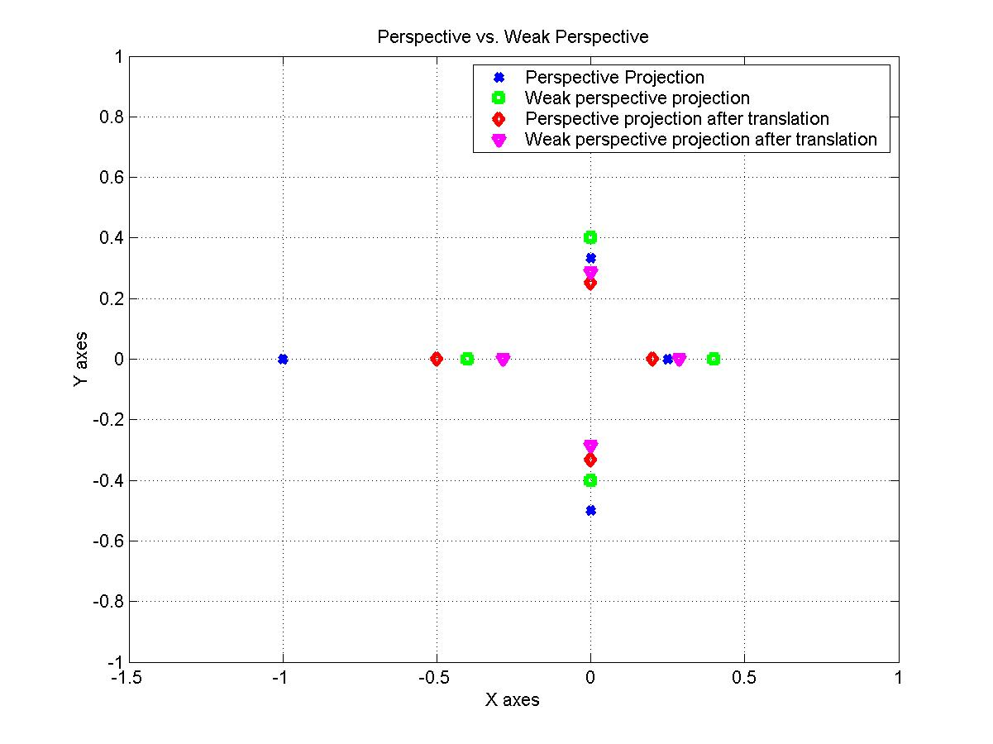
e.
function A = my_ssd(P,Q)
A = sum(sum((P-Q).^2)) ;

f. 20 pts (Def. of your Distance 2pts + plot 18pts)
1. What is the distance from the object to the camera?
There could be lots of ways to measure the distance. The simplest one is the average of Euclidean distances of the points in the object from the focal point.

function objtr(P, tr_vector)
no_pts = size(P) ; tvector = tr_vector ;
tr_unit = [] ; errors = [] ; distance = [] ;

for k = 1 : no_pts(1)
tr_unit = [tr_unit ; tvector] ;
end

for i = 0 : 9
P = P + tr_unit ; pr = project_p(P) ; wpr = project_wp(P) ;
errors = [errors my_ssd(pr, wpr)] ;
distance = [distance sum(sqrt(sum(P.^2))) / no_pts(1)] ;
end

figure ; plot(distance, errors, 'bd-', 'LineWidth',3); grid on ;
xlabel('Distance') ; ylabel('Difference') ;
title('Error plot wrt Distance(X-Y Mov)') ;

Results) First graph (The left of the two): objtr(getobj, [0 0.5 1])
Second graph (The right of the two): objtr(getobj, [1 0.5 0])

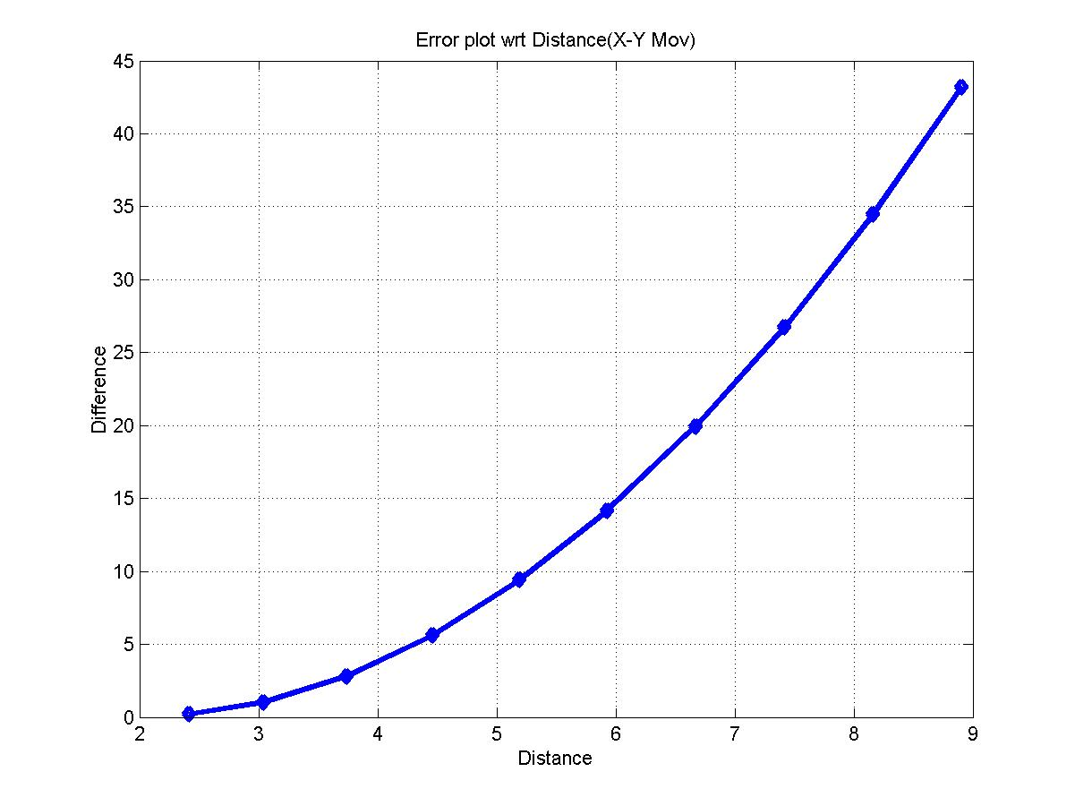
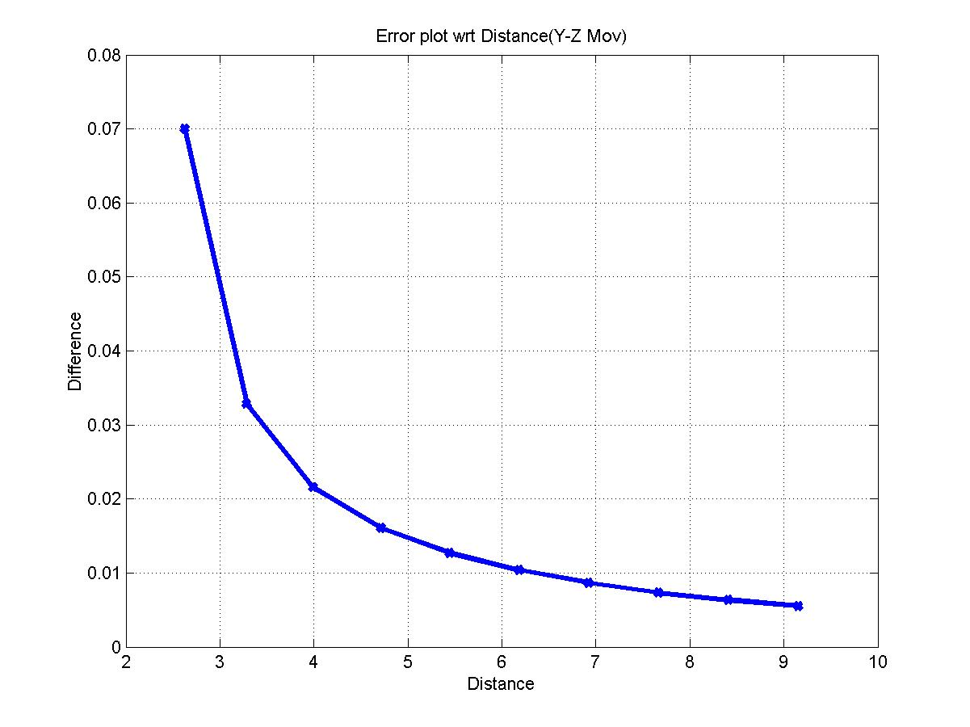
g. 10pts (7 what it tells + 3 other factors)
- What it tells
Error ≈ |X/Z’ – X/Z)| (X can be substituted for Y)
Let’s assume the standard deviation of Z coord. is σ.
Error ≈ X σ |1/(Z∙Z’)|

So the Error depends on X, Y, Z value and σ. As the Z components of the points increase, the error decreases. As the X (or Y) components increase, the error increases. The graphs above show this.
- Other factors: Orientation, shape, direction of movement, … anything reasonable
2.
a. 20 pts
x = X/Z

dx/dt = ( dX/dt Z – X dZ/dt ) / Z² = 1/3

x = 1/3 t + c, when t = 0, x = 1/3
x = (t+1) / 3

b. 20 pts
x = X/Z
( You also can use the fact dx/dt = ( dX/dt Z – X dZ/dt ) / Z² = -1/Z² )
dZ/dt = 1
Z = t + c when t = 1 , Z = 4
Z = t + 3

x = 1/(t+3) + c, when t = 1, x = 1/4
x = 1/(t+3)

C. 5 pts
x = 1/(t+3)
Hyperbola (Parabola, curve, straight line ... could not be an answer)

3.
a. 5pts
1. CD, mirror, spoon, monitor anything that shine can be selected as candidates.
2. What does this tell? : First of all, you can observe that the orientation of the surface with respect to the light source is an important factor of specular reflection. Then you also can see the intensity of the light source affects the degree of shininess. The surface of the object itself is also one of the crucial things related to the shininess. If the surface is smoother, it looks shinier. Finally the characteristic (absorbance, color) of material that makes up the object can change the shininess.
3. Mirror (Very shiny, made of glass reflective foil) > A spoon made of steel (shinny, made of steel) > Opaque plastic clipboard (not that shiny, made of plastic)

b. 5pts
The shape of the specular highlight depends on the shape of the object reflecting it. When the angle from the viewer to the surface to the light changes slowly as your gaze moves along the surface, the specularity is stretched out. This causes the specularity to be stretched a great deal in the direction of the can that is flat. The angle to the light changes faster as the light is closer to the can, so this
effect is diminished.

c. 5 pts
The moon appears to shine, but it isn't shiny. If it were, you could see the shape of the sun reflected in it (imagine what you'd see if the moon were a round mirror). (Any reasonable answer will do regardless of your choice.)

