1. Ransac

a)
function line = gen_line(pt1, pt2)

if sum(pt1 == pt2) == 2
return ;
end

A = [ pt1 ; pt2 ] ;

if det(A) ~= 0
sol = A \ [-1 ; -1] ; % Solution of ax + by +1 = 0
sol = [sol' 1] ;
else
if sum(pt1 == [0 0]) == 2 || sum(pt2 == [0 0]) == 2
sol = [pt1(2) + pt2(2) , -pt1(1)-pt2(1), 0] ;
else
sol = [pt2(2) - pt1(2) , pt1(1) - pt2(1), (pt2(1) - pt1(1)) * (pt1(2)-pt1(1))] ;
end
end

r = sqrt(sol(1)^2 + sol(2)^2) ;

line = [] ; line = [line, sol(1) / r ] ; line = [line, sol(2) / r ] ; line = [line, sol(3) / r ] ;

b)
function dist = line_dist(L, pt)
dist = abs(L * [pt 1]') % I assumed the line data is coming from a)

c)
i)
The line equation that formed by (0,1) and (2,1) is y = 1 so the length should be 1

ii)
The line equation that formed by (1,1) and (3,2) is
y -1 = ½ (x-1)

the line that passes (7,4) and is perpendicular to the line above,
y – 4 = -2(x-7)

The intersection point of these two lines is
½ (x+1) = -2(x-9)
x = 7 , y = 4
The point is on the line so the length is 0.

d) refer advanced part Problem 2.
function k = num_samples(n, m, p)
if m == n
k = 2 ;
else
k = ceil( log(1-p) / ( log(n+m) + log(n-m) - 2 * log(n) ) ) ;
end

e)
function pts_cor = verify(p1, p2, pts, eps)
l = gen_line(p1,p2) ;
pts_cor = [] ;
[no_pts dummy] = size(pts) ;
for i = 1:no_pts
if line_dist(l,pts(i, :)) < eps
pts_cor = [pts_cor ; pts(i, :)] ;
end
end

f)
function pts = test(n)
pts = [n 2] ;
for i = 1 : 8
pts(i, 1) = round(rand * 50 ) ; pts(i, 2) = round(25 + randn) ;
end

for i = 9 : n + 8
pts(i, 1) = round(rand * 50 ) ; pts(i, 2) = round(rand * 50 );
end

g)
function [L, pts, c] = ransac1(n)

pts = test(n) ;
k = num_samples(n + 8, 8, 0.95) ;
sel = 0 ; c = 0 ;
selected = [] ;

while (sel < k)
t1 = ceil( rand * (n+8) ) ; t2 = ceil( rand * (n+8) ) ;
if t1 > t2 % swap
t1 = t1 + t2 ; t2 = t1 - t2 ; t1 = t1 - t2 ;
end
if t1 ~= t2 && any(ismember(selected, [t1 t2], 'rows')) == false
sel = sel + 1 ; selected = [selected; t1 t2 ] ;
end
end

vote = zeros(1,k) ;

for i = 1 : k
pts_cor = verify ( pts(selected(i, 1), :) , pts(selected(i,2), :), pts, 2 ) ;
[vote(i) dummy]= size(pts_cor) ;
end

[max_val , max_loc] = max(vote)
selected(max_loc, :)
pts(selected(max_loc, 1), :)
pts(selected(max_loc, 2), :)

L = gen_line(pts(selected(max_loc, 1), :), pts(selected(max_loc, 2), :)) ;
pts_cor = verify ( pts(selected(max_loc, 1), :), pts(selected(max_loc, 2), :), pts, 2 ) ;

for i = 1 : k
if selected(i,1) < 9 && selected(i,2) < 9
c = c + 1 ;
end
end

plot(pts(1:8, 1), pts(1:8, 2), 'r.') ; hold on ;
plot(pts(9:n+8, 1), pts(9:n+8, 2), 'k+') ; hold on ;
plot(pts_cor(:, 1), pts_cor(:, 2), 'bs') ; hold on ;

x = [0 : 0.1 : 50] ;
y = (-x * L(1) - L(3)) / L(2) ;

plot(x,y, 'c.') ; hold off ;

pts = pts_cor ;

2. EM
a)
p₁(80) = 0.01, p₁(90) = 0.0097, p₁(100) = 0.0088, p₁(110) = 0.0075
p₂(80) = 0.0013, p₂(90) = 0.0022, p₂(100) = 0.0032, p₂(110) = 0.0046

w₁(x) = p₁(x) / ( p₁(x) + p₂(x)) , w₂(x) = 1 - w₁(x)

w₁(80) = 0.8808, w₁(90) = 0.8176, w₁(100) = 0.7311, w₁(110) = 06225
w₂(80) = 0.1192, w₂(90) = 0.1824, w₂(100) = 0.2689, w₂(110) = 0.3775

b)
w1_{mean} = (dot product of weights and it corresponding mean value) / sum(weights)
= 92.7778

Likewise,

w2_{mean} = 117.6860

c) new sigma = 16.3594

3.
a) origin (0,0)
r = 0 for all θ
b) r = 4(cos θ + sin θ)
c) r = 6cos θ + 7 sin θ

The figure is
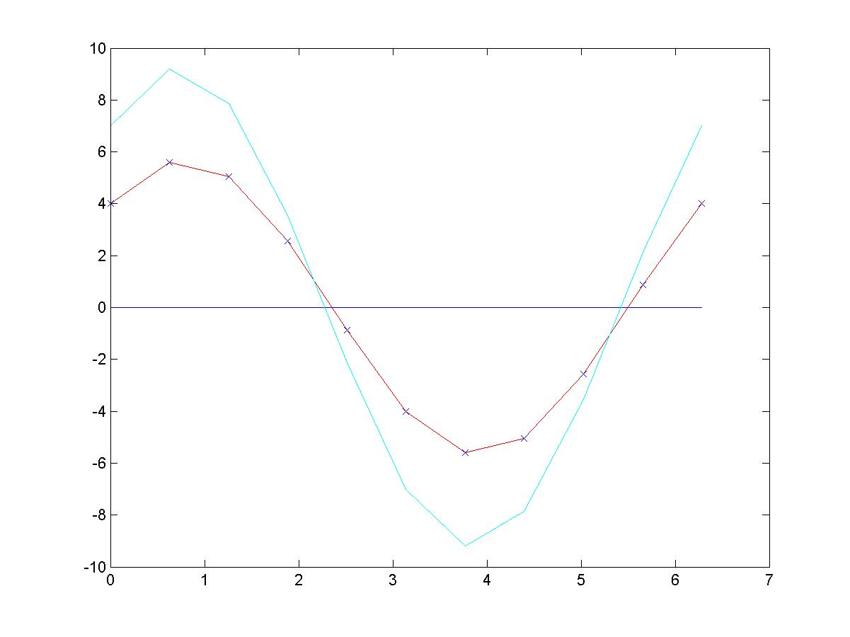
So your result should look like the graph above except negative r values.
Advanced assignment

1.
a) Fitting a line to data
function [a, b, c] = fit_lines( x, y, w )

[mx, nx] = size(x); [my, ny] = size(y);

wx = w.*x; wy = w.*y;

t1 = sum(wx.*x)/nx - ((sum(wx)/nx).^ 2) / (sum(w)/nx);
t2 = sum(wx.*y)/nx - (sum(wx)/nx) * (sum(wy)/nx) / (sum(w)/nx);
t3 = t2;
t4 = sum(wy.*y)/nx - ((sum(wy)/nx).^ 2) / (sum(w)/nx) ;

M = [t1, t2;t3, t4];

% find eigenvalue lamda and eigenvector x

[V, D] = eig(M);

% select eig vactor
a = V(1,1);
b = V(2,1); % tangent : ax + by + c
c = -1 * (a * sum(wx) + b * sum(wy))/sum(w);
d1 = sum((w.*(a.*x + b.*y + c)).^2);

a = V(1,2);
b = V(2,2); % tangent : ax + by + c
c = -1 * (a * sum(wx) + b * sum(wy))/sum(w);
d2 = sum((w.*(a.*x + b.*y + c)).^2);

if ( d2 >= d1 ),
a = V(1,1);
b = V(2,1); % tangent : ax + by + c
c = -1 * (a * sum(wx) + b * sum(wy))/sum(w);
end

b) Estimating the parameters of lines using EM

function o = line_em(sigma, simple);
% Sigma is the amount of noise to use.
% simple = 1 means least squares, = 0 means total least squares.

theta1 = 2*pi*rand;
theta2 = 2*pi*rand;
a1 = cos(theta1);
b1 = sin(theta1);
a2 = cos(theta2);
b2 = sin(theta2);
% Initialize the lines so that their orienation is drawn from a uniform
% distribution.
c1 = 4*rand - .5;
c2 = 4*rand - .5;
% This initialization is more ad-hoc. Ideally, it should be based more on
% the data.

x=0:0.05:1; y=(abs(x-0.5) < 0.25).*(x+1)+(abs(x-0.5) >=0.25).*(-x);

pts = [x;y]+ sigma*randn(2,length(x));

% It is interesting to flip the x and y coordinates of the test set, as in
% the commented out line above. With that data, least squares and total
% least squares work very differently.

% Initialization

sigma1_cur = .3;
% Initialization of sigma
sigma2_cur = sigma1_cur;

for i = 1:11
% Just do 11 iterations. I changed this as I debugged.

% Expectation step

dists1 = a1*pts(1,:) + b1*pts(2,:) - c1;
dists2 = a2*pts(1,:) + b2*pts(2,:) - c2;

prob1 = exp(- (dists1.^2 / sigma1_cur^2));
prob2 = exp(- (dists2.^2 / sigma2_cur^2));
if any(prob1==0 & prob2==0)
keyboard
end
weights1 = prob1./(prob1+prob2);
weights2 = prob2./(prob1+prob2);

if mod(i,1) == 0
plot_line_em(pts, weights1, a1, b1, c1, a2, b2, c2);
% 'last iteration'
% This just visualizes the results. I changed 0 to other numbers to look
% at either every iteration, every other iteration, etc....
end

% Maximization step

if simple
[a1,b1,c1] = simple_weighted_line_fit(pts, weights1);
[a2,b2,c2] = simple_weighted_line_fit(pts, weights2);
else
[a1,b1,c1] = weighted_line_fit(pts, weights1);
[a2,b2,c2] = weighted_line_fit(pts, weights2);
end
% I implemented least squares, and total least squares to compare.

dists1 = a1*pts(1,:) + b1*pts(2,:) - c1;
dists2 = a2*pts(1,:) + b2*pts(2,:) - c2;
% You must recompute the distances before computing sigma.
sigma1_cur = max(eps, sqrt( (sum((dists1.^2).*weights1) ...
+ sum((dists2.^2).*weights2)) / length(pts)));
sigma2_cur = sigma1_cur;
end
o = 1;

function [a, b, c] = simple_weighted_line_fit(pts,weights)
% This does least squares, not total least squares.
xx = sum((pts(1,:).^2).*weights);
x = sum(pts(1,:).*weights);
w = sum(weights);
xy = sum( (pts(1,:).*pts(2,:)).*weights);
yy = sum((pts(2,:).^2).*weights);
y = sum(pts(2,:).*weights);

R = [xx, x; x, w]\[xy;y];
norm = sqrt(1+R(1)^2);
a = -R(1)/norm;
b = 1/norm;
c = R(2)/norm;

2. Ransac
a) Note that the noise itself is 2-dimensional Gaussian function though, the line equation we are considering is ‘y= 25’ – only the vertical perturbation matters. Therefore we can degenerate the error dimension to 1 (around y = 25 axis) and the probability that a point lies within 2 from L equals trivially the summation of sigma function from -2σ to 2σ (=0.9544).

The expected number of point lies within x of L can be computed as follow:

2 * (P(0) * (k-2) + P(dy) * (k-2) + P(2dy) * (k-2) + …… + P(n * dy) * (k-2))

where P(x) = the probability that the size of the noise is x, n * dy = 2 and dy → 0.

Finally,

2 * (P(0) * (k-2) + P(dy) * (k-2) + P(2dy) * (k-2) + …… + P(n * dy) * (k-2))
= (the summation of sigma function from -2σ to 2σ) * (k-2)
= 0.9544 * (k-2)

b) Since we assumed uniform distribution, the probability that a point lies within 2 from V equals trivially the ratio of the rectangular area defined by the lines x = 23 and x = 27(wrt the 25 * 25 square). So the probability is (4 * 50) / (50 * 50) = 0.08.

The actual distribution on the number of points(x) -out of n points-that will lie within 2 of V is binomial distribution such as:

P(n,x) = _{n}C_{x} (0.08)^{x} (0.92)^{(n-x)}

If the noise is independent to each other and the n is quite large then it is well known that the probability above can be approximated to Gaussian distribution N(μ, σ) where μ = n * p and σ² = n * p * (1-p)

P(n,x) ≈ N(n*0.08, sqrt(n * 0.0736))

c) From a) and b), the probability of the expected number of incorrect noise points lie within 2 of V is greater than that of correct points within L is

0.9544 * (k-2) + 2 < (# of pts within 2 of V) = x

sum-of-gaussian(x, ∞) where mean = 0.08n , σ = 0.0736n

= sum-of-normal-gaussian( ((0.9544 k + 0.1) – 0.08n) / sqrt(0.074n), ∞ )

Note that we ignore the set of intersection points between 2 of L and 2 of V by the definition of the problem. If we have to consider this intersection points, it gets much harder.

d)
Let’s assume that the incorrect lines are all vertical/horizontal.

(i)
The number of random pair of points we have to sample to ensure at least 95 % probability that one pair comes from the line L is

- The total number of the point we have is n + k
- The probability we choose a pair that comes from the line is
_{k}C₂ /_{n+k}C₂ = p ( or (k/(n+k))² –sampling with replacement)
- The probability we fail to choose a pair that comes from the line is (1 – p)
- The probability we choose at least a pair that comes from the line when we randomly choose m pairs from the points we have is 1 – (1-p)^{m}
- So it is pretty simple to calculate m using different p

m > log(0.05) / log(1-p) where p = _{k}C₂ /_{n+k}C₂

Therefore on the fixed value k (=10) and n = 10, 30, 50, the number of random pairs to sample is 11, 51, 117 (or 11, 41, 107) respectively.

(ii)
The expected number of points matched to L
The points from k : 2 + ( 0.9544 * 8) = 9.6 points
(The points from n : n= 10, 10 * 0.08 = 0.8 points
n= 30, 30 * 0.08 = 2.4 points
n= 50, 50 * 0.08 = 4 points are ignored)

(iii)
Using the result of c), Lets define

P_{pn} = The probability that “the expected number of incorrect noise points lie within 2
of V is greater than that of correct points within L” given k points from L and
n points of noise.
= sum-of-normal-gaussian( ((0.9544 k + 0.1) – 0.08n) / sqrt(0.074n), ∞ )

m = The number of pairs of the points that we have to choose/sample to include
at least one pair of points from L.(with 95% prob.) at i).
= log(0.05) / log(1-p) where p = _{k}C₂ /_{n+k}C₂

P_{c} = The probability that we choose a pair of points that lie on L.
= _{k}C₂ /_{n+k}C₂

P_{c(i,m)} = The probability that we choose i pairs of points that lie on L out of
m sampled pairs. = _{m}C_{i} P_{c}^{i} (1 - P_{c}) ^{m-i}
Suppose we have sampled m-pairs of points from n+k points in the image. Then the probability that one of the incorrect lines will match more points than correct line would be

1 – (prob. of finding the correct line)

Then the probability of finding the correct line is

- When we have i pairs (out of m-pairs of points in the sample) of points that lie on L, the probability of finding correct line is
(1- P_{pn})^{m-i}

- So the probability of finding the correct line is
P_{correct} = ∑_{i=0..m} (1- P_{pn})^{m-i} P_{c(i,m)}

Finally we can get P_{incorrect} = 1 - P_{correct}

