Practice Problems for Quiz 2
CMSC 426

Texture: For each pair of the following 1D textures, indicate whether we can distinguish between them using 1) the histogram of the image; 2) a Markov model in which each pixel depends on its immediate neighbors; 3) a Markov model in which each pixel depends on its two immediate neighbors.

A: 0 1 0 1 0 1 0 1 0 1 0 1 0 1 0 1 0 1
B: 1 1 1 0 0 0 0 0 0 1 1 1 1 1 1 0 0 0
C: 0 1 1 0 0 0 1 1 0 1 1 1 0 1 1 0 1 1

Clustering:

RANSAC for lines: Write the equation for a line containing the points (0,1) and (2,1). Compute the distance from this line to the point (5,2). Write the equation for the line formed by the points (1,1) and (3,2) and compute the distance to the point (7,4).

Suppose an image has 10 points. 5 come from a line, and 5 are due to noise. We randomly select a pair of points, and use them to form a line, for RANSAC. What is the probability that this pair of points comes from the line? How many pairs of points must we sample to have greater than .5 probability that at least one pair will come from the line? To simplify things, you may assume that every sample is chosen with equal probability each time, so that we may pick the same pair of points more than once.

Hough Transform: Suppose a line is described by the equation y = mx + b. Suppose we divide the space of m’s and b’s into 100 buckets. We divide m and b into ten intervals each: (-5 -4), (-4, -3) … (4, 5). Which buckets will we need to fill up as buckets that correspond to lines that go through the point (2,1)? What is the range of angles relative to the x axis that a line can have when m is in the range (4,5)? What about when m is in the range (0,1)? Explain how the answer to these questions shows some limitations of our bucketing scheme, and suggest a better one.

Kmeans: Suppose we have points at the locations: (1,3) (4,7) (2,9) (2,2) (3,6), and we pick centers at (1,4) (4,4). Which points will be assigned to each center? What will be the location of the new centers?

Suppose we have five points and two centers, as above. Place an upper bound on the number of possible iterations that k-means can perform before it converges.

Stereo: Consider stereo matching of two 1D images obeying the ordering constraint, so that we could use a shortest path algorithm. Let the cost of an occlusion be .01, and the cost of matching two pixels be the squared difference of their intensities. Compute all minimum cost matches for the 1D images, v1 = [1 0 1 1]; v2 = [1 1 0 1]. Write your answers as a disparity map for v1. That is, a map of [0 x 1 1] means the disparity for the first point in v1 is 0 (v1(1) = 1 matches v2(1) = 1, the second point is occluded and unmatched, the third point has a disparity of 1, (v1(3) =1 matches v2(2) = 1), and the fourth point has a disparity of 1 (v1(4) =1 matches v2(3) = 0). Of course, this example is not necessarily a minimum cost matching. There may be one or more matches with the same minimum cost.

Consider two cameras whose image planes are the z=1 plane, and whose focal points are at (-10, 0, 0) and (10, 0, 0). We’ll call a point in the first camera (x,y), and a point in the second camera (u,v). Points in each camera are relative to the camera center. So, for example if (x,y) = (0,0), this is really the point (-10,0,1) in world coordinates, while if (u,v) = (0,0) this is the point (10,0,1).

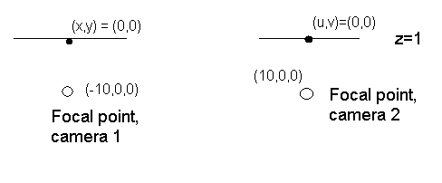
Suppose the point (x,y) = (1,0) is matched, with disparity of 2, to the point (u,v) = (-1,0) in the second camera. What is the 3D location of this point?

Suppose the point (x,y) = (7,7) is matched with disparity of 4 to the point (u,v) = (3,7). What is the 3D location of this point?

CHALLENGE PROBLEM: Consider points that lie on the line x+z=0, y = 0. Use the same stereo set up as before. Write an analytic expression giving the disparity of a point on this line after it projects onto the two images, as a function of its position in the left image. So your expression should only involve the variables u and d (for disparity). Your expression only needs to be valid for points on the line that are in front of the cameras, ie., with z > 1.

In this problem we will consider a 2D world with x-z coordinates. That is, imagine the problem takes place in a horizontal slice through the world in which y is constant. Consider a camera with focal point at the origin, and an image plane (line, really since we’re in a 2D world) along the line x+z = 1. We have an image, and we want to rectify it so that we get an equivalent image on the line z=1. We will parameterize the first image using the variable u, and the second image using v. In our original image, the camera center was at the point on the line x+z=1 nearest the focal point, ie., (½, ½). So we call this point u=0 in the original image. If we move a distance of 1 along the line x+z = 1, the u value increases by 1. So, for example, the point with world coordinates (x,z) = (0,1) has a u value in the image of sqrt(1/2). Suppose the first image appeared to have intensities that increased linearly. That is, the first image had intensities described by the equation I(u) = u (don’t worry about negative intensities).

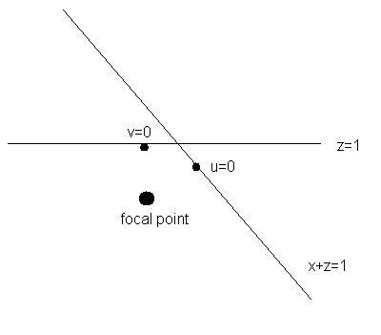

In the rectified image, what is the intensity at v = 0 (that is, in the point in the image with world coordinates (x,z) = (0,1))?

After rectifying the image, write an equation describing the image intensity as a function of v.

Structure from Motion:

Which of these is a rotation matrix: [1,1,1;1,1,1;1,1,1] * 1/sqrt(3) or (abbreviate sq2 = sqrt(2)), [sq2,sq2,0;sq2,sq2,0;0,0,1] or [sq2, -sq2, 0; sq2, sq2, 0; 0,0,1]?

Consider the following image matrix:
0 1 0 0 1
0 0 1 0 1
0 0.6 0.8 -0.4 ?
0 -0.5 0.5 0.25 ?
Each column represents the image of a different point. The first two rows are the x and y image coordinates of each point in the first image. The second two rows are those coordinates in the second image.
- Find a valid way of filling in the question marks with possible coordinates of the fifth point in the second image.
- Find a line that describes all possible locations of this point.

