Thank you for your interest in the CS Spring 2019 Internship & Career Fair!
Please take a moment to read through this important event information.
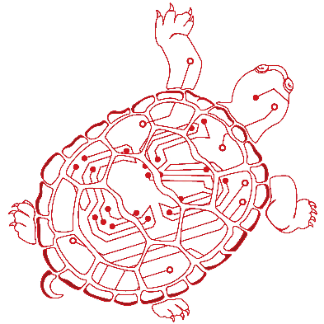
TABLE OF CONTENTS:
- Date, Location, & Deadlines
- Shipping Materials to CS Career Fair
- Directions to Campus & Hotel Information
- Parking Information
- Inclement Weather
- Scheduling On-Campus Interviews
- Other Recruiting Opportunities
- Contact Names for Questions

- DATE, LOCATION DEADLINES & FAIR SCHEDULE
Monday, February 11, 2019
The Hotel at University of Maryland
7777 Baltimore Avenue
College Park, MD 20740
Schedule:
2:00pm – 3:00pm
- Check In
- Booth Set up
- Refreshments will be available until 7:30pm
3:00pm – 4:00pm
- Computer Science Career and Internship Fair
Power Hour for full time positions– Attendees looking for full time employment will have a head start to enter the CS Career Fair and meet with employers.
4:00pm – 8:00pm
- Computer Science Career and Internship Fair
  - Please note that this event is exclusively for Computer Science and Computer Engineering undergraduate and graduate students. We will review the resumes of students outside the major prior to admission to the event.
Logistical Information
Assigned spaces include a 6ft rectangular table, 2 chairs, and a black tablecloth. You are welcome to bring any display, materials, swag, etc. that fits within these parameters. If you have any unique displays, please contact Miriam Friedman, mfried@cs.umd.edu, for advance approval. Please note that the venue cannot accommodate outside food including pizza, popcorn, cotton candy, etc. Individually wrapped items are acceptable.
Payment & Cancellation Deadlines:
Payment Deadline: Payment must be made by February 4, 2019.
Cancellation Deadline: In order to receive a full refund - or to not be billed if you haven't already paid - cancellations must be made in writing via email at mfried@cs.umd.edu by February 4, 2018. All other cancellations made after this deadline - including cancellations made by employers who register after the cancellation deadline - will receive no refund.
Table Forfeit: If you do not arrive by 3:00pm on the day of the fair and have not contacted us via email at mfried@cs.umd.edu to make alternative arrangements, we will consider your booth forfeited and reserve the right to assign it to another exhibitor.
- SHIPPING BOOTH MATERIALS
We will be using Advantage Expo and Trade Show to coordinate all freight shipping for the fair. Please see the attached Fair Shipping Kit for more information. The deadline to ship materials is January 31, 2019. Please do not ship any materials directly to the University Career Center or to the XFINITY Center.
Any package delivery inquiries should be directed to Advantage Conference & Expo at CustomerService@AdvantageExpo.com or 410.789.5000
3. PARKING INFORMATION
Parking will be limited, and more information will be available closer to the event.
4. INCLEMENT WEATHER
In the event of inclement weather, check http://www.umd.edu, call 301.405.7669, or tune into local radio and television stations beginning at 6:00 am to hear if the University of Maryland, College Park campus is closed or if campus opening will be delayed for a specific number of hours. If the University of Maryland is closed due to inclement weather, then all events will be canceled. We will be in touch with you via e-mail to discuss the next steps. If no information is given, you should assume the campus is open.
5. SCHEDULE FREE ON-CAMPUS INTERVIEW SESSIONS
If you haven't already done so, don't forget to reserve a free interviewing room in our Center utilizing our "Room Only Schedule" option. This will allow you the flexibility of scheduling your own interviews with candidates you meet while at the fair (meaning you will lock candidates into your schedule much faster). Employers who utilize our On-Campus Interviewing Program in conjunction with the fair report higher levels of success. So if you haven't reserved a room do so soon. Space is very limited. Visit our information page for more information or contact Michael Maiden at mmaiden@umd.edu
6. OTHER RECRUITING OPPORTUNITIES:
The University Career Center & The President’s Promise will also host a campus-wide Spring Career & Internship Fair on September 21 & 22, 2019
7. CONTACT NAMES, QUESTIONS?
- Fair Logistics:
  - Miriam Friedman, mfried@cs.umd.edu, 301.405.0688
- Payment Information:
  - Michael Martucci, mmartucc@umd.edu, 301.314.7238
- Careers4Terps job/internship postings and On-Campus Interviews:
  - Michael Maiden, mmaiden@umd.edu, 301.405.2780
- Shipping Information:
  - Mary Michael, CustomerService@AdvantageExpo.com, 410.789.5000
- Information about joining the Corporate Partners in Computing Program:
  - Maria Johnson, mjohn@cs.umd.edu, 301.405.7990
Sincerely,
Miriam Friedman
Events & Community Relations Coordinator
Department of Computer Science
University of Maryland

