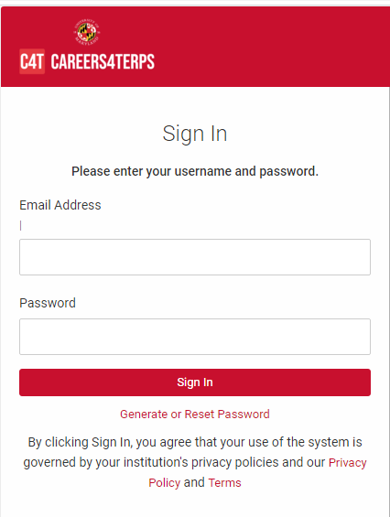
- On the day of the event, you can access the fair 60 minutes before the start time.
- Go to the Careers4Terps Employer login page: https://umd-csm.symplicity.com/employers/ to log in. Your username is your email. If you do not have or do not remember your password, click on the “Generate or Reset Password” link.
- Once logged in, access the fair by navigating to the left navigation bar and clicking on Event Registration/Career Fairs. Navigate to the event and click on the red “View Chats” button.
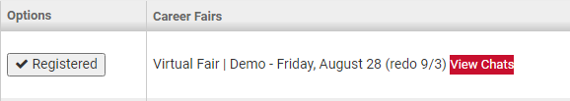
- Confirm your 1-on-1 Video Chat information. If any changes are needed, please update accordingly by clicking the “Video Chat Instructions button”.
The Video Chat Instructions should include the direct link to the video conferencing platform you will be using to connect with students 1-on-1.
The Alternate Chat Instructions provide space to list an alternate way for candidates to contact you if technical difficulties arise.
Note:
Use the hyperlink function so students can click on your direct link without having to copy and paste into another browser.
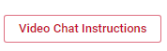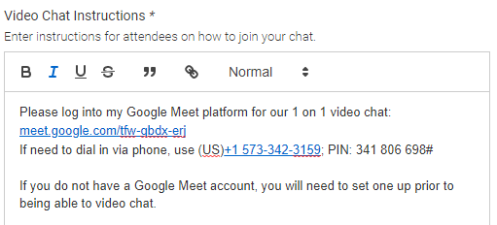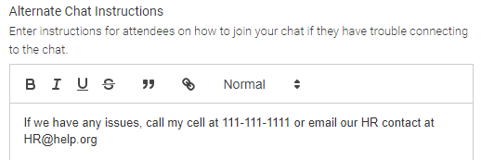
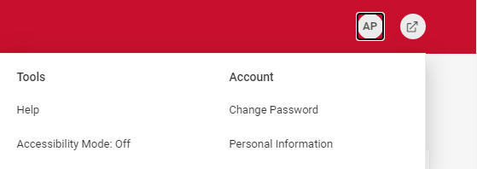
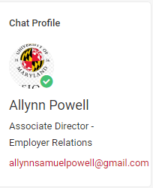
- Individual representatives will not have access to modify the Profile Information (Name, title, division, email). Only the registering contact (person who registered on behalf of the organization) or the event organizer can make these changes. Please reach out accordingly if changes are needed.
umd@umd.edu
- Add a profile picture that would be viewable to students who view your organization page or get in the queue for a video chat. Click on the Account icon with your initials and select “Personal Profile”
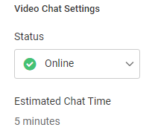
- Your employer registering contact has set the expected chat time per student, which is the same for all representatives at your company. You cannot modify this on an individual level. However, if you need more or less with a candidate, independently extend or end the chat time during your video chat session.
- Set your Status to Online
- Start your video meeting using the video link provided in Video Chat Instructions and keep your video meeting running for the entire length of the fair. Make sure you have two browser windows open side by side - one for video meeting and another one for Careers4Terps, so you can see the timer.
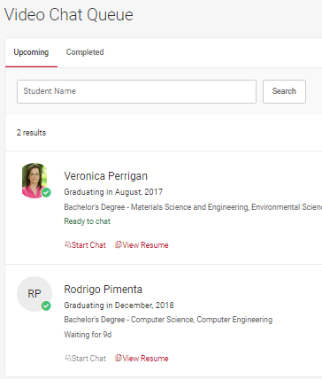
- If your Alternate Chat Instructions include a phone number, make sure to have your phone handy if students experience technical difficulties.
- When the fair starts, you will see students lining up in your queue.
- Select the student at the top of the list, unless the student is already video chatting with another representative from your company. Be patient, as it may take a couple of minutes for a student to join your video chat.
- Once you have started to video chat with a student, watch the timer which will count down from the maximum time to zero. When time is up, you will see an alert and hear a “ping” sound. You will have the option to extend the time by 2 minutes or end the chat.
- When you are done, click End Chat in Careers4Terps, and Dismiss Attendee in your video meeting. This enables you to keep your video meeting running, ensuring no overlap between students. Do not close your video meeting!
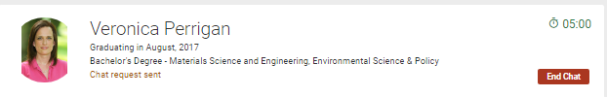
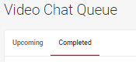
- The student will now show in the Completed side of your Video Chat Queue. You can make notes that might be helpful, including Interested or Not Interested in, contact to pass candidate along to or anything else worth remembering. This information is not be seen or shared with the student.
- To view and invite the next student(s) in your queue, click back to the “Upcoming” side of your Video Chat Queue.
- Repeat steps 12-16 for the duration of the fair event.
- If the next student in your queue is busy chatting with another company, they will show as “busy” and you will not be able to select them. They will however, remain at the top of your queue and will show as available to chat once they are free.
- If you need to step away for a short break, set your Status to “Busy”. Students can continue to join your queue. Once ready to resume, change your status back to “Online” and invite the next student to video chat.
- If you need to take a longer break and no other representative from your company is Online, then set your Status to “Offline”. Students will be notified that you are no longer online and will likely leave your queue.
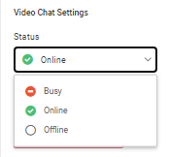
- The system will automatically send you resumes of students who were in line, but did not have a chance to connect with you
- When the fair is over,
  - Please set your Video Chat Status to “Offline”
  - The Careers4Terps system will automatically send you resumes of students who were in line, but did not have a chance to connect with you.
  - You can filter students by Overall Feedback and download resumes

- Before or during the fair, you can generate interest in your organization by inviting students to video chat. From the breadcrumbs at the top of the page, click on “Career Fairs” then click on the “All RSVP’d Students” tab, use Advanced Search to find students of interest, select them and use the “Mail To/Invite to Chat” button. A default email template will appear which you can customize and send out.
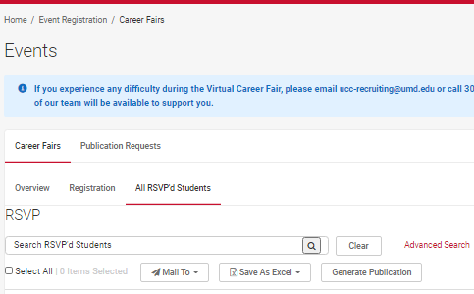
- If you need assistance at any point during the event, please refer to the blue note at the top of the Careers4Terps fair page for contact information for the event organizers.
