University of Maryland College Park
Department of Computer Science
Research experiences for undergraduates:

Cominatorial Algorithms Applied Research (CARR)

Summative Report 2016, 2017, 2018

National Science Foundation Grant #

Principal Investigator: William Gasarch

Evaluator, Report Author: Audrey Rorrer

Highlights
The REU Site at the University of Maryland College Park offers projects that either (1) apply theory to practice directly, such as Security, Machine Learning, Data Science, or (2) apply theory to practice indirectly (or speculatively), such as cryptography, quantum computing, graph theory. The purpose of these projects is to broaden the students’ horizons, break down artificial walls between disciplines and expose them to problem formulation/modeling. We highlight the following notable successes from our CISE funded program (10 students each summer):
- 67% of our students who’ve graduated are pursuing graduate degrees in computing (8 out of 12 graduates)
- 52% are from underrepresented groups in computing
- Students report overwhelmingly positive experiences in survey means and comments
- Making friends and learning (about research/graduate school) are major themes

Pictures from CARR 2018
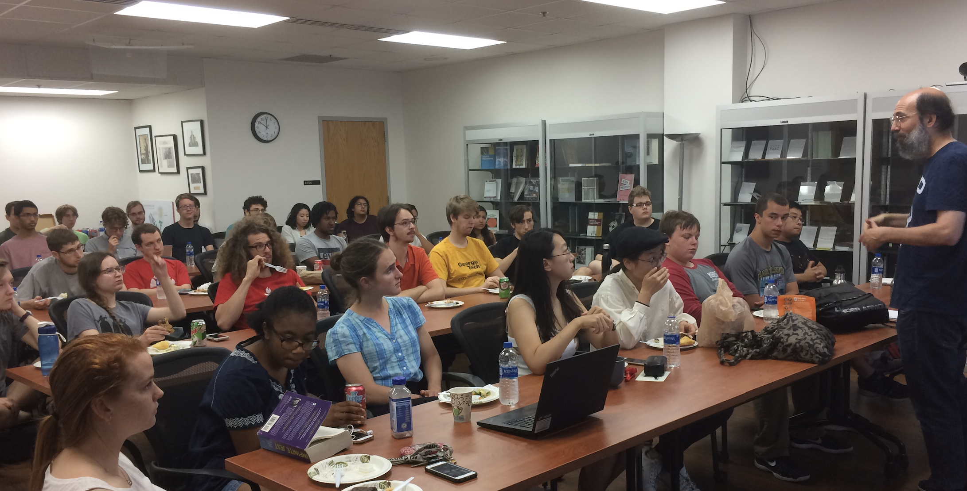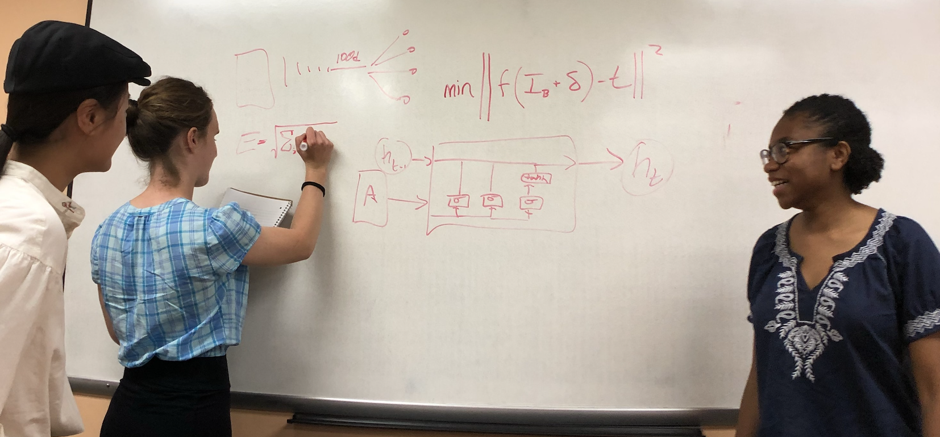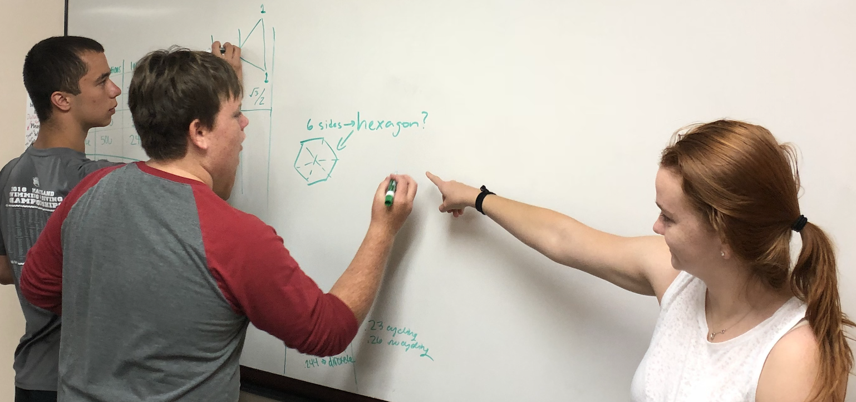
Bottom Photos: Students working in teams to solve computing issues, mapping out calculations.
Top Photo: Students lunch and learn with faculty mentors showcasing research projects.

Total Participant Demographics:
In the last three years of the CARR Site [2016, 2017, 2018], we have hosted approximately 10 CISE REU funded students per summer with a total of 63 participants, 31 of which were funded by CISE and 32 funded by other sources. Over half of all the participants (n=63), 54%, are from underrepresented student groups (women, African American, Hispanic, Native American), and 43% were from non-research institutions [68% of the CISE funded cohort were from non-research institutions]. So far, twenty-three of our 63 students have graduated with bachelor degrees, and among those, 18 (78%) are currently pursuing graduate degrees in computing. The other five students are employed in computing domains, at reputable companies like Google, The Hartford, and DSC Technologies. There were 161 applicants in 2016, 196 applicants in 2017, and 199 applicants in 2018, an indication of good recruiting and a competitive program. to our program across the three years, working on 21 research projects. This report provides a summary of the 31 students supported under the CISE REU projects.

Overview of Research Projects
Our projects conduct research that bridges theory with computing practice. We highlight examples by themes.
Security: Dana Dachman-Soled has mentored two projects on security. In 2017 her group
studied the tradeoff between security and efficiency. In 2018 her group studied side channel attacks in the cloud. Both projects involved both cryptography and security.

Applied Math: John Dickerson has mentored two projects that directly apply theory.
One was on how to allocate Kidney's and the other was on automating the process
of choosing candidates (e.g., for graduate school) while keeping diversity.
Both projects involved graph theory, algorithms, and machine learning.

Scheduling: Samir Khuller has mentored two projects having to do with scheduling.
In both cases the groups took known algorithms and modified them to work on
real world data.

Some of our projects were more theoretical. However, a practical motivation
may be realized in the future.

Cryptography: Jonathan Katz supervised two projects on implementing crypto systems
that are hard to break but perhaps, at this time, too slow. One was based on
group theory and the other on lattices. While not practical today, this research
hopes to make these systems practical in the future.

CISE Funded Participant Demographics
A focus of the CARR program is attracting underrepresented students into computing research, and preparing students for graduate study. Another goal is to provide students who wouldn’t otherwise have access to research, opportunities to explore research. More than half of our 31 CISE funded students, 68%, were from non-research schools. Women and underrepresented ethnic minority groups (African American, Hispanic, Native American) comprised 52% of our CISE funded participants.
Retention: All thirty one CISE funded students who participated in the Summer 2016, 17, and 18 programs have been retained in computing. Twelve students have completed bachelor degrees, eight of whom are pursuing graduate degrees, and four employed in technology. Nineteen were continuing to pursue computing degrees at the time of this report. All students indicated an interest in graduate school in survey responses, based upon mean scores hovering near 4 on a 5 point scale.
Figure 2. Gender, Ethnicity and Non-Research School Distribution of 31 CISE REU Funded Participants
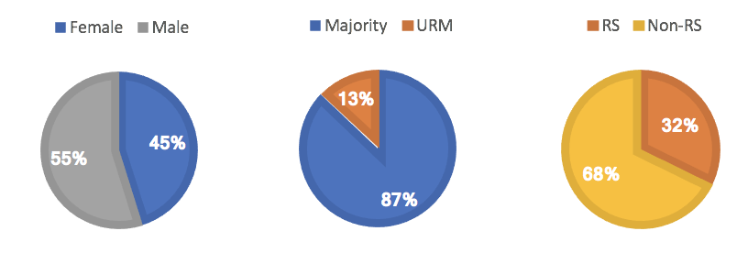
DEM URM is all ethnicity except Asian and Caucasian

Publications and Products: Among the students funded under this CISE REU grant, there have been 7 products and publications in 2016 and 2017. Conference submissions in 2016 included one in LATIN, and one for BITCOIN. The 2017 cohort submitted three conference proposals: ACM Fairness, ALENEX, and ASILOMAR, which included the software package. The 2018 cohort has submitted two papers which are currently under review. The complete list is in Table 1.

Table 1. Publications and Products
REU-CAAR 2016
Elementary Methods vs Generation Functiosn: Loaded Dice By Berlanga, Gasarch, and Tian. FAIR-LOADED-DICE
Approximate Fair Loaded Dice By Berlanga, Gasarch, and Tian. APPROX-FAIR-LOADED-DICE
Select and Permute: An Improved Online Framework for Scheduling to Minimnize Weighted Completion Time by Khuller, Li, Sturmfels, Sun, Venkat. SCHEDULE Accepted to LATIN 2018.
Incentivizing Double-Spend Collusion in Bitcoin By Kevin Liao and Jon Katz. BITCOIN-DOUBLE
On the Algebraic Eraser and the Ben-Zvi, Blackburn, and Tsaban Attack by Cioffi, Latz, Liu, and Soria. ERASER
The Can't Stop Game by Canakci, Serrano, Roy, and Kruskal CANTSTOP
Incentivising Blockchain Forks via Whale Transactions by Kevin Liao and Jon Katz. Fourth Workshop on Bitcoin and Blockchain Research (BITCOIN 2017) BITCOIN-FORK
REU-CAAR 2017
The diverse cohort selection problem: Multi armed bandits with varied pulls. by Candice Pullman, Samsara Counts, Jefferey Foster, John Dickerson. Submitted to IJCAI-2018 (International Joint Conference on AI)
Learning Optimal Diverse Partitions by Samsara Counts, John Dickerson, and Joel Lewis. (In Preparation, to be submitted to NIPS (Neural Information Processing Systems)).
Maximizing final winnings on Jeopardy! by Jessica Abramsom, Natalie Collina, William Gasarch. Presented at Regional AMS meeting in October 2018 (Buffalo). Submitted to College Math Journal. JEOP
Side-Channel Attacks on BTrees by Dachman Dana-Soled, Shir Maimon, Robert Metzger, Stuart Nevans Locke, Aria Shahverdi, Laura B. Sullivan-Russett. To be submitted to CCS 2018 (ACM conf on Computers and Communications Security). SIDECHANNEL
Job-Resource scheduling Problems By Tu Luan and Samir Khuller. To be submitted to ALENEX 2019 (Algorithmic Engineering and Experiements).
UMD Rideshare Website by Xi Chen (mentored by Samir). This is a website to organize car pooling that may be used by UMCP. RIDESHARE
PhasePack: A Phase Retrieval Library by Rohan Chandra, Ziyuan Zhong, Justin Hontz, Val McCulloh, Christoph Studer, Tom Goldstein. Asilomar conference on Signals, Systems, and Computing, 2017.PhasePack Paper, PhasePack Package

PANT

Budget and Lab Management
REU student participants were allocated funds as follows.

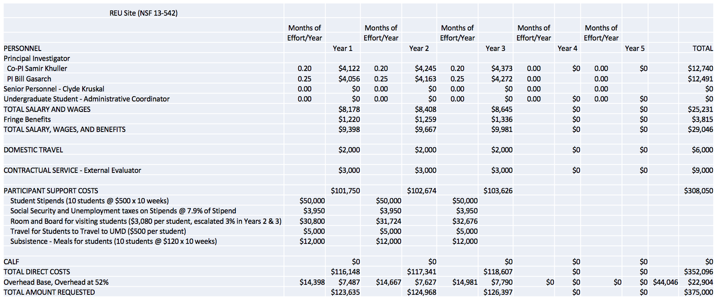

To ensure that students were not isolated in their research, labs were managed with a tiered mentoring structure and worked in small teams.

Activities and Professional Development
Students worked in teams of 2-4 people. Mentors met with students often early in the program,
and less frequently as the summer progressed. During the first week of the summer programs, each of the mentors give talks to the students to provide everyone with an overview of all of the projects. This enabled the students to talk to peers and faculty from outside of their group. Most of the students lived in campus residence halls, as a means of ensuring comradery and preventing feelings of isolation.

There were many intellectual and social activities held throughout the summers, both formal and informal. Intellectual activities included talks on computer science topics, delivered by the faculty mentors and others. Additionally, we held discussions of what makes a good scientist that was facilitated by an expert in the area. The students orchestrated f a reading group on Matroids on their own.

The social activities were frequent and mostly ad hoc, and driven by the students. The students had lunch together every weekday, with Mondays being a formal full cohort luncheon day.
At the Monday lunches, the students would often work on a math problem together, a unique way of blending social and academic activities. The students also held game nights where they played rather sophisticated games. Because students lived in the same residence hall, they frequently organized their own trips out to Washington, DC.

Student Outcomes and Evaluation

Former REU Student Retention
The CARR program has supported a total of 63 students in 2016, 2017, and 2018. Among these students, twenty-three have completed bachelor degrees, and 18 of those are currently pursuing graduate degrees in computing. 78% of the graduated alumni are seeking advanced degrees. Among those students who are still pursuing undergraduate degrees (n=40), one is working at MIT Lincoln Lab. One senior has begun applying to graduate programs, and another has obtained a position at Microsoft. For the 31 students who have been NSF funded, 19 are still seeking computing degrees; among the 12 students who have graduated are 7 are pursuing graduate studies, and 5 are employed in computing.

Student Attitudinal Outcomes
Students participated in a pre and post assessment of attitudes toward computing and research at the start of their summer experience, and repeated at the end. Students were invited to participate in t a pre-survey on the first day of their REU experience, and repeated the same survey during the last week of their experience. The survey was developed and deployed by the CISE REU Evaluation Toolkit project (NSF #1346847 and #1645846) which is a validated instrument for measurement of the common indicators among the sites (Rorrer, 2016). computing self efficacy, intentions to attend graduate school, attitudes about computing, help-seeking/coping behaviors, research skills, professional identity as a scientist, scientific leadership skills, and mentoring satisfaction (post-survey only). The items asked questions on a Likert -type rating scale with 5 being a positive indicator and 1 being a negative indicator.
Due to the small number of REU participants each summer, outcomes comparisons were limited to nonparametric statistical tests. A Wilcoxon Signed Ranks Test was conducted each summer to compare cohorts on any changes between pre and post survey. In 2016, 7 out of 10 students participated in the pre and post surveys. No statistically significant changes were found. However, positive gains in mean scores across several constructs were observed. In 2017, all 10 students participated in the pre and post surveys. Significant change was observed for self-efficacy (Z = -3.186, P = 0.001), research skills (Z = -2.760, P = 0.006), scientific leadership (Z = -2.437, P = 0.015). No significant change was found in any other indicators, despite positive gains in intentions to attend graduate school, attitudes towards computing, and scientific identity. The mean scores for these constructs improved at the end of the summer. For summer 2018, significant gains were observed for research skills at post-survey, Z= -2.701, P =.007. Gains were also seen in self-efficacy, grit, leadership and scientific identity, although not statistically significant. Table 2 below presents the means and significance value on the seven constructs measured by the Survey at pre and post survey.
Additionally, the mean score for mentoring satisfaction, assessed at post survey only, is presented. The items were rated on a 5 point Likert scale of 5 being the strongest favorable rating and 1 being the strongest unfavorable rating. The mean scores above 4 are considered to be high favorable ratings; additionally low standard deviations are present in 2017 and 2018, indicating overall satisfaction with both the program mentoring and the program overall.
Table 2. Mean Scores and Significance for Pre and Post Surveys on CISE REU Common Indicators
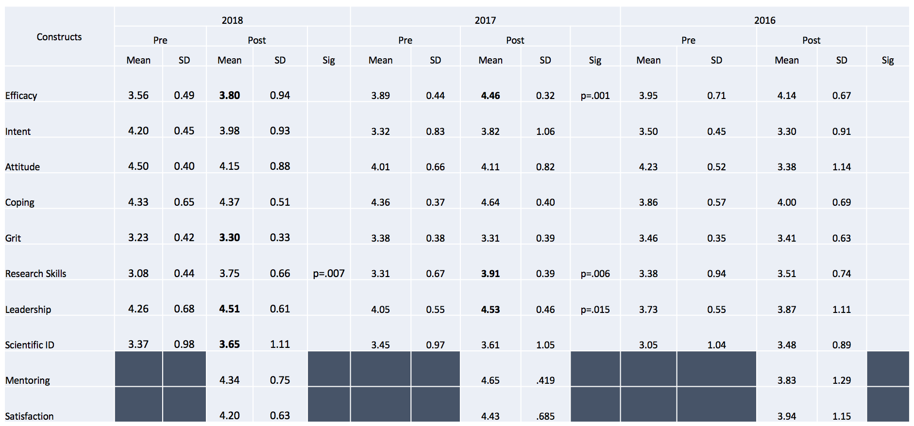

Student research skills, self efficacy, and scientific leadership skills increased significantly in 2017, and research skills increased significantly in 2018. Most constructs show positive increases, although not significant, at post-survey. These are positive indicators of the strength of the program, especially given recent findings among CISE REU programs showing declining interest in graduate school (Rorrer, Allen, and Zuo, 2018).

Qualitative Feedback of Student Experiences.
The post survey contained three open-ended items inquiring about the student experience broadly. Students were asked to provide comment on what was most rewarding during the REU, what was frustrating, and to offer any additional comments. Students responses indicated the most valuable components in the program were learning about graduate programs (2), meeting peers/making friends (6), mentoring and team work (3), learning about other research projects (1), learning new things (1),and seeing their projects come together (2).

What was most frustrating was not seeing results (3), feeling lost in the beginning (4), going down a ‘wrong’ path (2), little interaction with faculty advisor (2), not fitting in (2), some general complaints with space/housing (2).

Formative Evaluation
Students survey results indicated overwhelming positive experiences across all three summers. Gains were made in most constructs, although not always statistically significant. Students provided more comments to the open-ended item about rewarding aspects of the program. The overarching theme from these comments indicate that the relationships formed between peers and faculty are powerful and positive encounters. The fact that a large number of program alumni have matriculated into graduate study is also indicative of the program’s success.

The comments about frustration components of the program center on feeling lost and undirected. This is a natural part of the research experience, but, it can be pivotal in cases when a student does not connect with peers or have an advisor who is available. One suggestion for future program implementation is to set expectations with faculty advisors to be available in the first few, critical weeks, of student research engagement.

Conclusion (and summative for NSF proposal)
The CARR REU Site has clearly met its primary goals of attracting underrepresented students into computing research, and preparing them for graduate study. A stated focus of the program is to provide students who wouldn’t otherwise have access to research opportunities the chance to explore research. The summative program evaluation consists of review of student participation demographics, student longitudinal outcomes pertaining to degree attainment, and pre and post survey analyses as a reflection of these stated program goals. Evaluation was conducted by Audrey Rorrer, PhD, an evaluator in the College of Computing and Informatics at UNC Charlotte, and PI of the CISE REU Evaluation Toolkit (NSF ##1346847; 1645846).

The CARR REU Site at the University of Maryland College Park has demonstrated successful student outcomes from 2016, 2017 and 2018 cohorts. The program has supported 31 students from NSF CISE, all of whom are retained in computing. Among the students who have graduated, 67% are in graduate programs (8 out of 12 graduates). More than half of the students are from underrepresented groups in computing (52%) and are from non-research colleges (68%). Surveys deployed at the start and end of each summer program have indicated positive experiences for students. Open-ended comments reveal a strong sense of community among the students and faculty, and enjoyment in making friends and learning about research. Survey constructs have consistently shown gains at post-survey, with statistically significant increases for research skills, self-efficacy, and scientific leadership skills. Mentoring scores are high as are overall program satisfaction. The fact that a large number of program alumni have matriculated into graduate study is also indicative of the program’s success, especially given the national context showing decreasing interest in graduate school over time (Rorrer, Allen, Zuo, 2018).

References
Rorrer, A. (2016). An evaluation capacity building toolkit for principal investigators of undergraduate research experiences: A demonstration of transforming theory into practice. Evaluation and Program Planning, 55, p103-111. DOI:10.1016/j.evalprogplan.2015.12.006

Rorrer, A., Allen, J., Zuo, H. (2018). A national study of undergraduate research experiences in computing: Implications for culturally relevant pedagogy. Association for Computing Machinery Special Interest Group on Computer Science Education (SIGSCE) 2018 Conference Proceedings,
Baltimore, Maryland.

